Name: __________________________
Date: ___ / ___ / ___
Total Internal Reflection
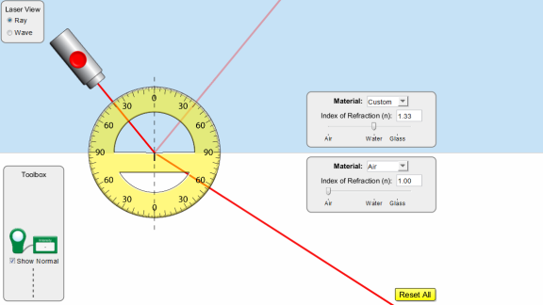
Setup: Head to the website http://phet.colorado.edu/en/simulation/bending-light and download the simulation. When it opens, change the Laser View to ‘Ray’ and you’ll be all set up.
Part 1: Total Internal Reflection
As light travels from one material to another there is often refraction and reflection. There are some points, however, where the beam is totally reflected. We call this phenomenon total internal reflection.
Experiment with the simulation until you get a ray of light that achieves total internal reflection. You can switch the materials around using the tool box on the right-hand side. What were your first and second materials in this case?
__________________________________________________________________________________________________
Using the protractor, measure your angles of incidence and reflection. Remember, all angles are measured from the normal.
$θ_{i}$ = _______ $θ_{r}$ = _______
Can you achieve total internal reflection when light is trying to travel from glass to air? ______________________________
Can you achieve total internal reflection when light is trying to travel from air to glass? ______________________________
Can you achieve total internal reflection when light is trying to travel from water to air? ______________________________
Can you achieve total internal reflection when light is trying to travel from air to water? ______________________________
Can you achieve total internal reflection when light is trying to travel from glass to water? ____________________________
Can you achieve total internal reflection when light is trying to travel from water to glass? ____________________________
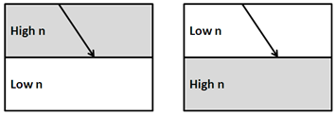
Based on the 6 previous scenarios, in which of the following illustrations could you possibly get total internal reflection?

Part 2: The Critical Angle
The critical angle is the angle of incidence that provides an angle of refraction of 90-degrees. It is the very first point where you get total internal reflection.
Using the Protractor, determine the critical angle of the following interfaces:
Glass to Air: _________
Water to Air: _________
Glass to Water: _______
Using Snell’s Law you can solve for an expression for the critical angle, $θ_{C}$. I’ll get you started with the first two steps. Finish the rest to solve for $θ_{C}$.
$$n_{1}sinθ_{1}=n_{2}sinθ_{2}$$
$$n_{1}sinθ_{C}=n_{2}sin⁡(90°)$$

$${ θ}_{C}=$$

Using your new expression for the critical angle, determine the critical angles for the following interfaces. Show your work below.
Glass to Air

Water to Air

Glass to Water

Do these results confirm the critical angles you calculated with the protractor?

