States of matter: The particle model
In this simulation we will be investigating the states of matter liquid, solid and gas. Through our investigation we will explore how the particle model of matter is represented throughout the simulation. Also observe the four basic principles of the particle model of matter:
- Matter is made up of tiny particles.
- There is empty space between the particles.
- The particles are in constant motion.
- There are forces that act between the particles.
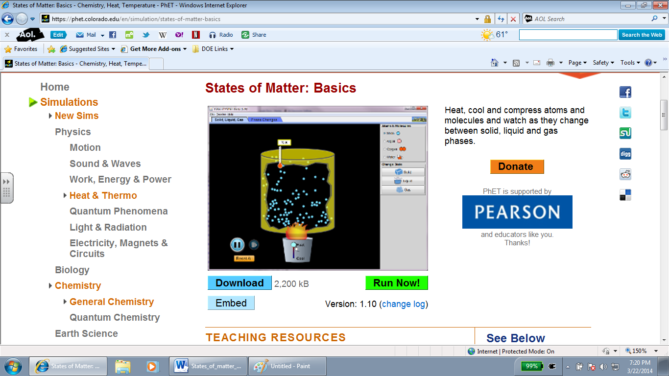
- Click on the link: http://phet .colorado.edu/en/simulation/states-of-matter-basics
- Click on States of Matter: Basics
- Once you see the simulation screen shot, click “Run Now!”
- Have the document and simulation open. You can switch between the document and the simulation in order to complete the activity.

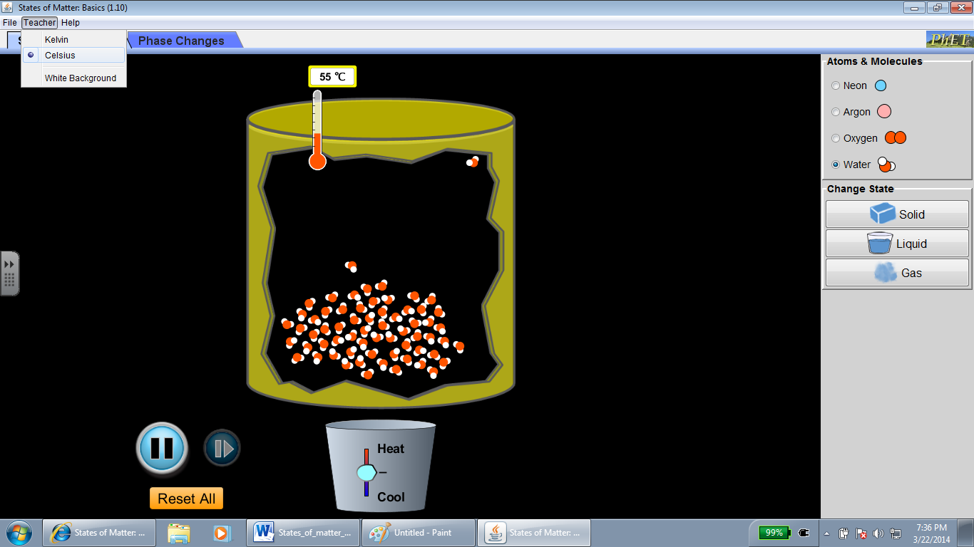
Explore(5 minutes):
Take 5 minutes to freely explore the simulation.
Once you are done exploring. Press the “Reset All” button to begin.
- Under the Atoms and Molecules section on the right hand side, click on water.
- On the teacher section, right next to file change the temperature measurement to Celsius.
- On the right hand side, click on liquid. Observe how the water molecules are moving at this temperature. How would you describe the movement of these particles?
- Continue to do the same for solid and gas. Observe how the water molecules are moving at this temperature. How would you describe the movement of these particles?

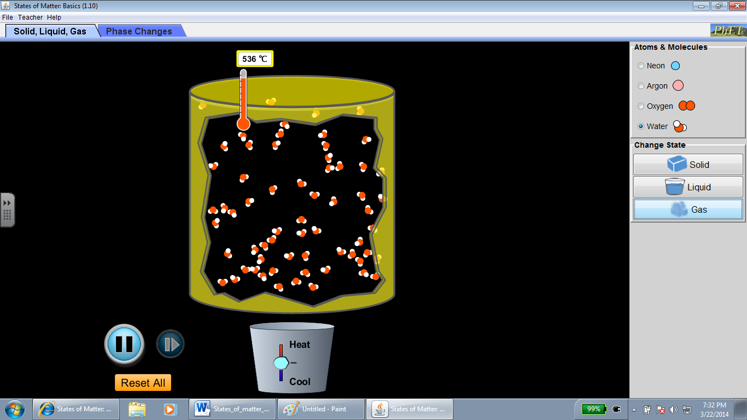
(This is how your screen should look like when you clicked on gas.)
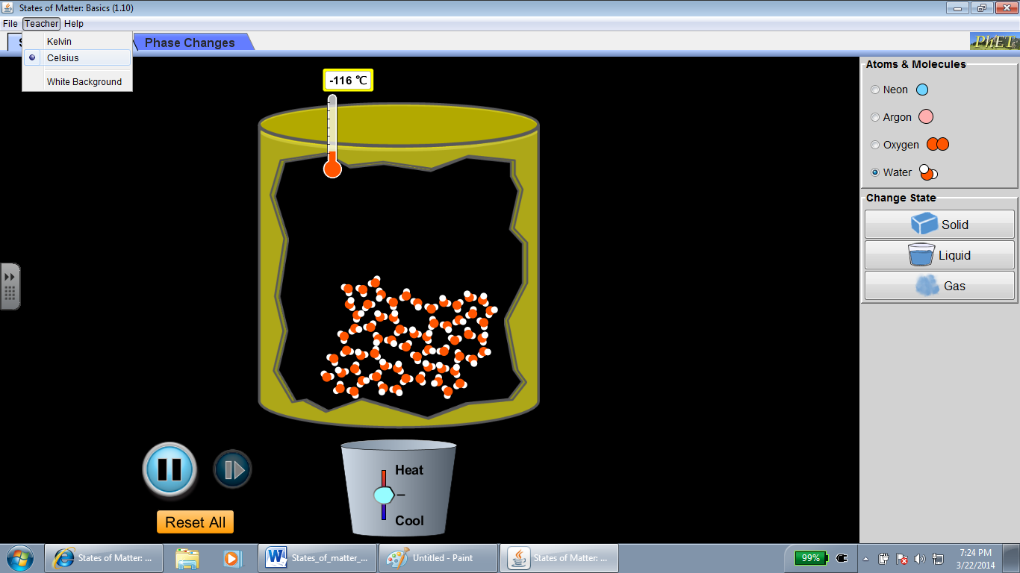
(This is how your screen should look like when you clicked on solid.)

Explain (15 minutes)
States of matter and particles (In your response to the to the following questions use the following words when appropriate. increase, decrease, particles, molecules)
- Draw a picture of what you saw when you were exploring the simulation.

- What happened to the water when you it changed from a liquid, solid, and gas?

- What happened to the water molecules when you changed the temperature?

- Was there anything else in the container besides water?

Now we are going to click on the phase changes section of the simulation. We are going to take a look at a closed container with an air pump connected to the container. Before you move on I want you to make a prediction. If we pump air into a closed container of water, would you expect anything to change inside of the container? Describe your prediction below.
Prediction:

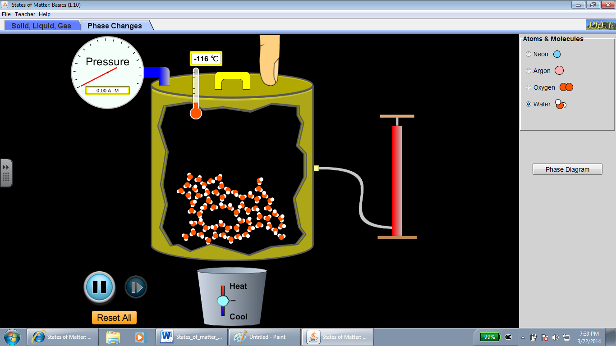
(Closed container with water molecules)

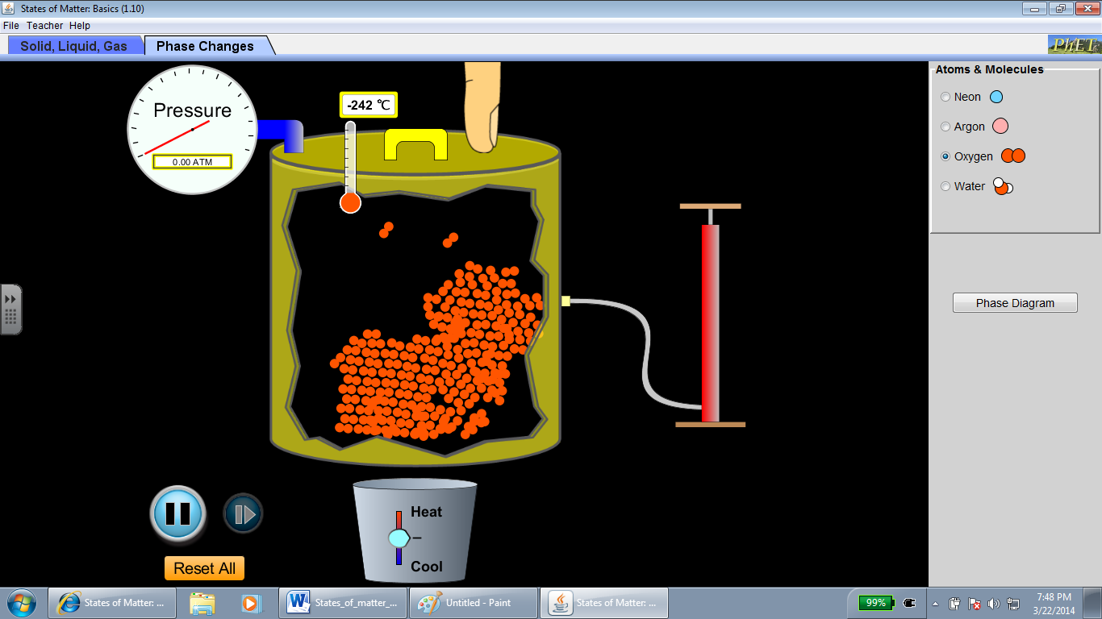
(Closed container being filled with air)

Once you are done making your prediction, continue on to the following activity:
- Make sure to click on the “Reset All” all button.
- On the Atoms and Molecules section click on water.
- Click on the air pump on the right hand side and begin to pump air into the container. Keep on going until you have a good amount of particles inside your container.

- Draw a picture of what you saw as you were exploring the website.

- Is there anything that you discovered about air that surprised you?

- After finishing both activities, we can say that air and water are made up of particles. Reflect on step 3 in which you pumped air into the closed container. If you kept on pumping would it be possible to fill the container? (If you need a visual you can use the simulation) What else is a property of matter that can explain whether or not this container can be filled?

Apply(5minutes)
- If you took an empty balloon and weighed it, then took that same balloon and filled it with air would you expect the weight of the balloon to change? If you think that the weight would not change explain why? If you think it would change explain why? Draw and record your data below.

