Pendulum Lab

Introduction

In this activity you will investigate how variables affect the motion of a pendulum. You will discover how the period of a simple pendulum depends on the length of the string and the mass of the pendulum bob. It's easy to measure the period using the photogate timer.

A simple pendulum has a mass m (bob) hanging from a string of length l fixed at a pivot point. When displaced to a small initial angle and released, the mass will swing back and forth in periodic motion. The period is the time it takes to complete one whole swing.

Background Information
One day in the late 1500s, a man named Galileo Galilei was sitting in church when he noticed the lamps hanging from the ceiling were swinging back and forth. Some of the lamps were making great big swings, and others were only making little swings back and forth, but they all went back and forth pretty regularly. Galileo was a curious man, and so he decided to use his heartbeat to measure how long it took the pendulums to swing back and forth. He was very surprised by what he learned. Today, you will repeat Galileo's experiment to learn about pendulums.

Procedure
How to open the simulation:
- Go to the simulation page: http://phet.colorado.edu/en/simulation/pendulum-lab
- Click to start.
- It will take time to load and then this screen appears:
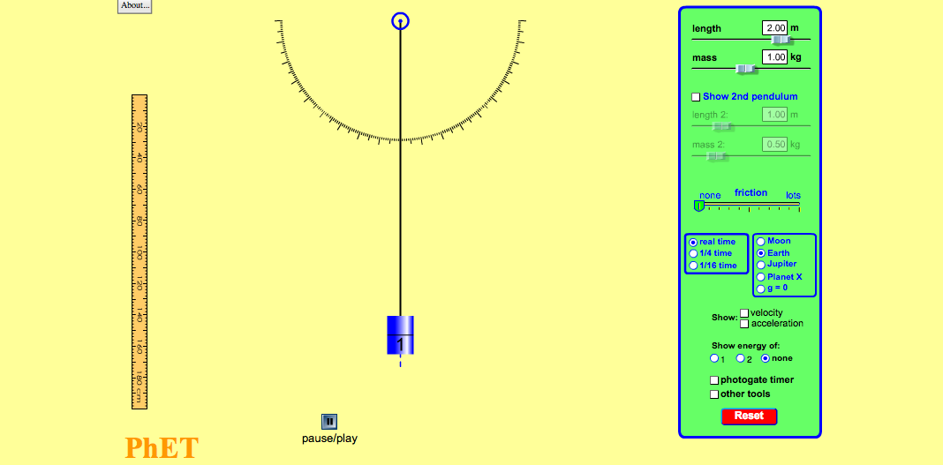

Aim: What variables might affect the time it takes for a pendulum to make a full swing?

Predictions:
- Does the mass of the bob affect the number of swings? Explain.

__________________________________________________________________

- Does the length of the pendulum affect the number of swings? Explain.

__________________________________________________________________

Explore:

Free Exploration:

For the next 5 minutes become familiar with the simulation. Change various features such as mass, length etc.

Next: Click and conduct the following investigation.

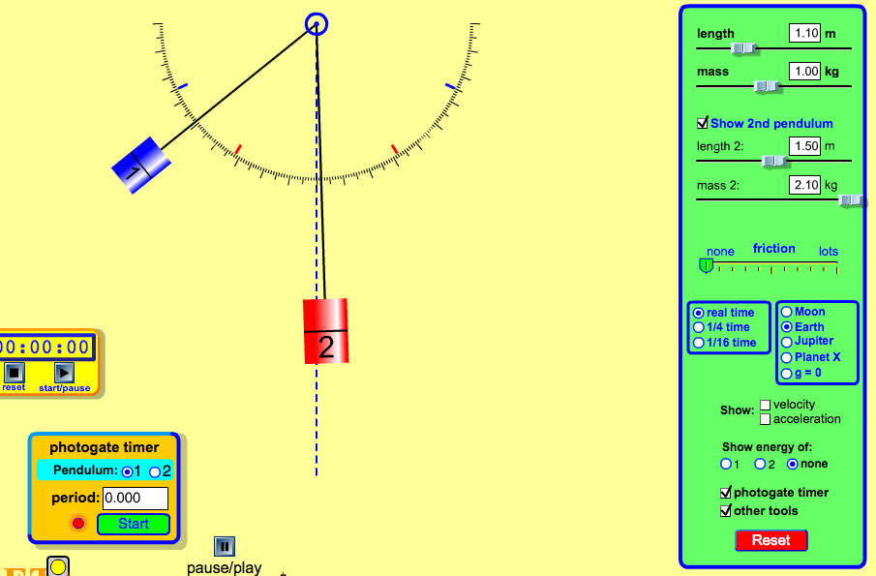

PART 1

MASS AND NUMBER OF SWINGS

Hypothesis:

As the mass of the pendulum _________________ the number of swings

will__________________.

- For this activity keep the length of both pendulums the same but different mass. Click 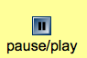. Start both pendulums at 90 degrees. Check the other tools button and use the timer to keep track of the time. Click play on the timer and then again so that the pendulums are released. Count the number of full swings for 30 seconds.
- Record the data on the table below.

 | Mass (kg) | Length (m) | Number of full swings in 30 Second
Pendulum 1
Pendulum 2

Did mass effect the number of full swings? Write a conclusion based on the data you collected.

Why do you think mass does not effect the time it takes for the pendulum to make a full swing?

_______________________________________________________________________

PART 2

Length and Number of Swings: How does the length affect the number of swings?

Write a hypothesis:

As the length of the pendulum _______________________ the number of swings_____________________.

- For this activity the mass should stay the same but the length will change each time.
- Click and conduct the following investigation.
- Use the photogate timer and record the period it takes for each length. Remember the period of a pendulum is the time it takes the pendulum to make one full back-and-forth swing. Click reset again.
- Next, use the timer (by clicking other tools) and observe the number of swings the pendulum makes each time you change the length.
- Each time you adjust the length, count the number of full swings in a 30 second interval.
- Make sure that the pendulum is released at the same position each time.
- Record the data on the table below.

Length of the Pendulum (m) | Period (s) | Number of swings  In 30 seconds
0.5

1

1.5
2
2.5

APPLY

Was your prediction correct?

How can you get the shortest period?

How can you get the longest period?

Write a conclusion on how the length of the pendulum affects the number of full swings?

________________________________________________________________________

