Title: States of Matter: Basics

Introductions
In this activity you will investigate the physical science of the three states of matter. You will see how the increase/decrease of temperature affects phase change through the movement of atoms/molecules. You will also see how pressure affects temperature and phase change.

1. Click this link: http://phet.colorado.edu/
This is a screen shot of the website:

2. Click the “Play with sims” button.
3. Click “By Grade Level” -> Click “Elementary School”-> Click “States of Matter: Basics”->Click “Run Now!”
4. It will take time to load and then this screen appears:

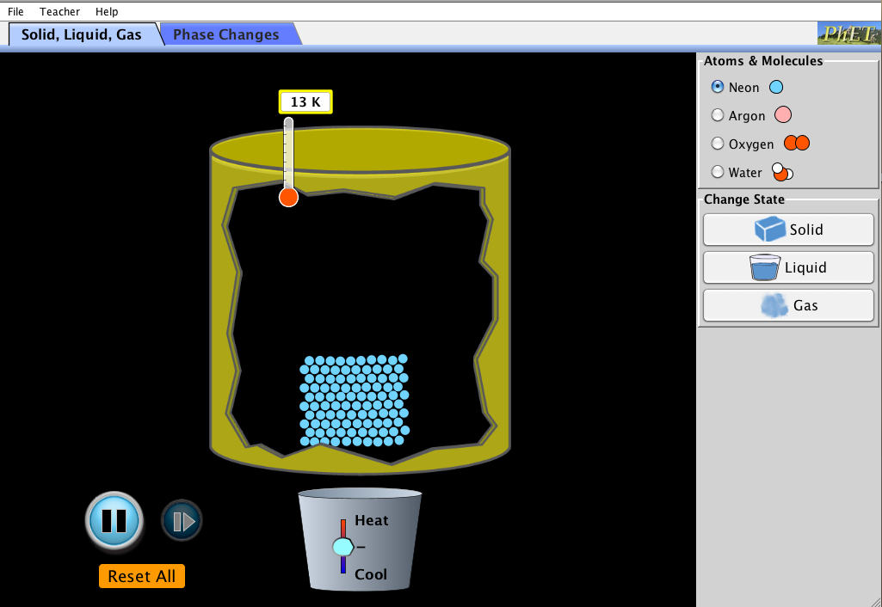

Switch between this document and the sim to complete the activity.

Exploration Phase

1. Click the “Solid, Liquid, Gas” tab on the sim.

2. Click one state of matter at a time and observe the movement of the atoms when changing the temperature.

3. Reset all changes before observing a new state of matter.

4. Freely explore the different movements of the atoms.

Questions

- How can you change the temperature?

- What happens to the atoms of a solid when the temperature increases? What happens to the atoms of a solid when the temperature decreases?

- What is the initial temperature of each state?

Explanation Phase

Aim: How does pressure affect temperature and the state of matter? Describe the relationship between temperature and phase change.

Predict: What will happen to pressure if temperature is increased? What will happen to pressure if temperature is decreased?

After you have reset all changes, make sure you still have the “Solid, Liquid, Gas” tab open.

Here are some concepts:
- When the heat/temperature is increased, the atoms will change phases from a solid to a liquid, and ultimately into a gas.
- When the temperature is decreased (cooled), the atoms will change phases from a gas to a liquid, and ultimately into a solid.
- The movement of the atoms change depending on their state:
  - Solid atoms are close together
  - Liquid atoms are slightly farther apart
  - Gas atoms are separated from one another
- Temperature Conversion:
  - Boiling Point: 373.16 K= 100°C= 212°F
    - Boiling is when a liquid becomes a solid
  - Melting and Freezing Point: 273.16 K= 0°C= 32°F
    - Melting is when a solid turns to a liquid
    - Freezing is when a liquid turns to a solid
  - Pressure is measured in atm (atmosphere)

- The greater the pressure, the higher the temperature, which will then change the state of matter.
- Pressure affects the boiling and melting point of the states of matter.

Use the sim to fill in the temperatures of each atom/molecule:

 | Neon | Argon | Oxygen | Water
Solid
Liquid
Gas

Come up with a relationship between states of matter and temperature.

Questions:
- As the temperature increases, which state of matter are the molecules in?
- As the temperature decreases, which state of matter are the molecules in?
- How can you use the movement of molecules to find out when a phase change has occurred?

Application Phase:

Click the “Phase Changes” tab:

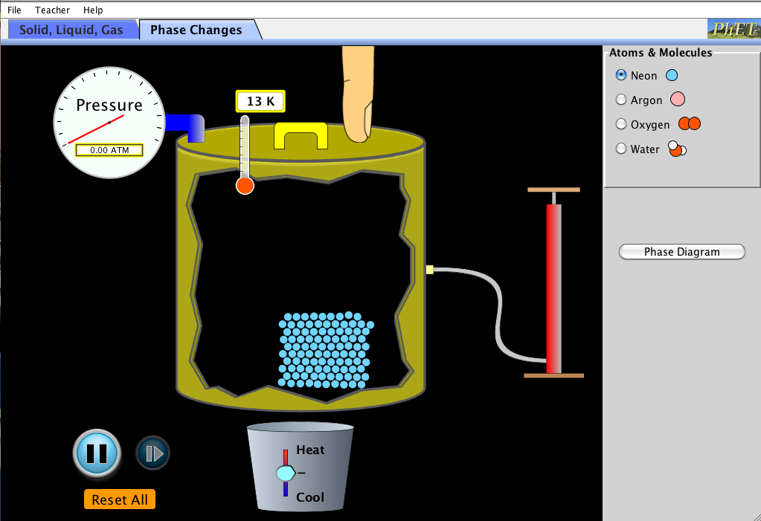

Click the “neon” option.

Using the sim, determine when a phase change occurs.

Neon | Temperature (K) | Pressure (ATM)
Solid
Liquid
Gas

Make a line graph showing the relationship between temperature and pressure.

Conclusions: Compare the data from both charts and explain:

- What do you notice about the temperature of each of the phase changes?
- How does pressure affect/contribute to temperature and phase change?
- When temperature increases, pressure _____________________________ (increases/decreases/stays the same)
- When temperature decreases, pressure _____________________________ (increases/decreases/stays the same)

