Launching Projectiles
http://phet.colorado.edu/sims/projectile-motion/projectile-motion_en.html

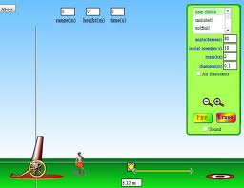
Procedure:
- Adjust the cannon to a 45 degree angle.
- Select Tankshell as the projectile.
- Select “Fire”
- Record the initial speed, mass, and diameter in the data table
- Drag the “+” sign on the ground to the site where the projectile landed.
- Record the distance traveled in the data table.
- Repeat steps 2-6 selecting a different projectile each time, and continue to fill in the data table.
- Select the “Air Resistance” box.
- Test each projectile again and measure the distance traveled. Record the Distance Traveled in the data final box of the data table.

 | Angle | Initial Speed | Mass (kg) | Diameter (m) | Distance Traveled  (you measure) | Distance Traveled  With Air resistance  (Your measure)
Tankshell | 45 °
Golfball | 45 °
Baseball | 45 °
Bowlingball | 45 °
Football | 45 °
Pumpkin | 45 °
Adult Human | 45 °
Piano | 45 °
Buick | 45 °

- How did the distance travel compare with the different projectiles?

- How did the distance travel compare with the different projectiles when Air Resistance was checked?

- What factor seemed to affect the distance traveled the most when Air Resistance was checked?

