Name:______________________
Lab: What Affects Resistance Ω ?
- Google circuit construction kit and click on the 1st link: Circuit construction kit (DC only)
- Click run now and allow Java to run
- Construct a simple series circuit containing one of each of the following: battery, lightbulb, switch, ammeter
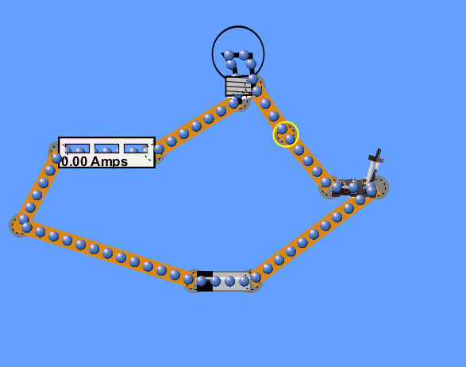
- Close the switch and record what the current in the circuit is in Amps ____________________
- Click on the voltmeter tool. Place the red wire to the left of the battery and the black wire on the right. Record the voltage in the circuit in Volts __________________________________
- Calculate the resistance in ohms of this circuit. R=voltage/current ______________________
- Now, add another light bulb to the circuit. What happens to the current in the wire?
__________________________________________________________________________
- What happened to the voltage in the circuit? ____________________________________
- Again calculate the resistance in ohms of this circuit using these new values
_________________________________________________________________________
- How did this new resistance compare to the 1st resistance calculated?
__________________________________________________________________________
- So because another light bulb was added ______________ decreased which caused ___________ to increase. This means that it is harder for electrons to flow through the circuit.
- What happened to the brightness of the original light bulb when the 2nd one was added?
___________________________________________________________________________
- How does this verify what was said in question 11? (hint: think about speed)
___________________________________________________________________________
- Now disconnect one of the light bulbs and add another battery to the circuit.
- What happened to the current in the circuit? ______________________________________
- What happened to the voltage in the circuit? ______________________________________
- Calculate the resistance of this new circuit ________________________________________
- How does this compare to the resistance you calculated in question 9?
___________________________________________________________________________
- What does this mean about the speed/ability of electrons to flow through the circuit?
____________________________________________________________________________
- Add the other light bulb back in and calculate the new resistance: ________________________
- Did the resistance increase or decrease? Why? ______________________________________________________________________________
- Give a brief summary of the relationship between voltage, current, and resistance.
__________________________________________________________________________________________________________________________________________________________________________________________________________________________________________

