Name: _________________________________________ Date: _______________________
Capacitor Intro Lab- PhET
Note: This lab assumes familiarity with the relationship C=Q/V and investigates physical factors that affect capacitance.
Directions: Access the PhET “Capacitor Lab” Simulation at http://phet.colorado.edu/en/simulation/capacitor-lab. On the iMacs you must click “Download Now” in blue, and then open the downloaded file. (Appears at the bottom of your window in Chrome or the upper right corner in Safari)
- Begin by familiarizing yourself with the setup. Start on the Introduction tab and check all boxes except Electric Field Detector. Move the red voltmeter wire to the top plate and the black wire to the bottom plate.
- Increase the battery voltage between 0 and 1.5V. Record observations for changes in each of the following as you increase the voltage.
  - Capacitance

  - Plate charge

  - Stored Energy

  - Voltage across plates (Read off of voltmeter)

  - How does the voltage across the plate compare to the battery voltage?

- What changes result from giving the battery a negative voltage?

- Remove the voltmeter and add the Electric Field Detector. Check “Show values” on the detector.
  - What is the electric field outside of the area directly between the plates?

  - How does the electric field change as you move from the positive to the negative plate?

- The above questions should be consistent with what you already know about capacitors. Summarize the relationships you saw in questions 1-4 below. (Remember up to this point you have NOT changed the capacitance)
  - Relationship between charge and voltage for constant capacitance

  - Two pieces of evidence for 5a:

Now, you will investigate physical factors that affect the capacitance.
- There are green sliders for plate area and separation. Predict and then find the relationship between a change in these values and the capacitance.
 | Prediction | Actual Relationship
Plate Area
Plate Separation

- Write a proportion (not an equation yet) that reflects the relationships you discovered in #7.

Finally, we will investigate the effect of a dielectric material. A dielectric material is some substance that is placed between the two plates.
- Go to the “Dielectric” tab. Add a capacitance meter, plate charge meter, and voltmeter to the simulation. Use the green “Offset” slider to move the dielectric material in between the plates, and increase the battery voltage to +1.5V.
  - List two quantities that increase with the addition of the dielectric

  - What quantity remains the same?

- Different materials have different effects when used as a dielectric. The degree to which a material affects (eventually) capacitance is referred to as its dielectric constant. Use the slider to control the dielectric constant in order to establish the following relationships for a constant voltage:
  - Dielectric constant and capacitance

  - Dielectric constant and charge stored

- Use your answer to 9a to incorporate the dielectric constant into the proportion you found in #7. Use a κ (lower case kappa) to represent the dielectric constant.

- Given the following dielectric constants, which would be (a) the best and (b) the worst suited to storing the largest possible amount of charge?
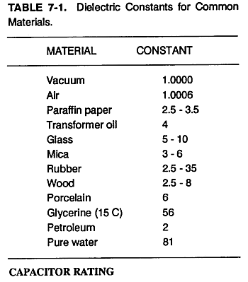

The final proportion you should have arrived at is $C∝\frac{κA}{d}$. The corresponding equation for capacitance is $C=\frac{κϵ_{0}A}{d}$, where C is capacitance, κ is the dielectric constant, ε₀ is a constant with a value of 8.56x10⁻¹² F/m, A is area of the plates, and d is the distance separating them.
- Use this formula to find the capacitance for a capacitor with a separation of 1mm of porcelain between the 10cm x 10cm square plates.

[Ans: 5.13x10⁻¹⁰ F]
- A 9x10⁻¹¹ F capacitor is made up of two circular plates (r=5cm) separated by 1.0mm. Find the necessary dielectric constant for this capacitor.

[Ans: 1.34 ]

