ENKA HIGH SCHOOL
SCIENCE DEPARTMENT
12TH GRADES PHYSICS
Experiment Name: Radioactive decay law
Aim: To draw radioactivity graph
Theory:
A nucleus of a radioactive element that emits an α-particle must transform into a nucleus of another element. The nucleus of the so-called ‘parent’ element loses two neutrons and two protons. Therefore the nucleon number (A) changes by 4 and the proton number (Z) changes by 2. The nucleus formed by this decay is called the ‘daughter nucleus’. We may express such a nuclear decay by the nuclear reaction equation

$${}_{Z}^{A}X→ {}_{Z-2}^{A-4}Y+{}_{2}^{4}{He}$$
(parent) (daughter) (α-particle)

The radioactive decay law enables us to determine a relation between the half-life of a radioactive element and the decay constant.

If a sample of a radioactive element initially contains N₀ atoms, after an interval of one half-life the sample will contain N atoms. If the half-life of the element is T½ from the decay law, we can write that

$$N=N_{0}e^{-λt}$$

Procedure:
1. Go to http://phet.colorado.edu/en/simulation/alpha-decay, and click on the “Run Now!”
button. The below window should appear.

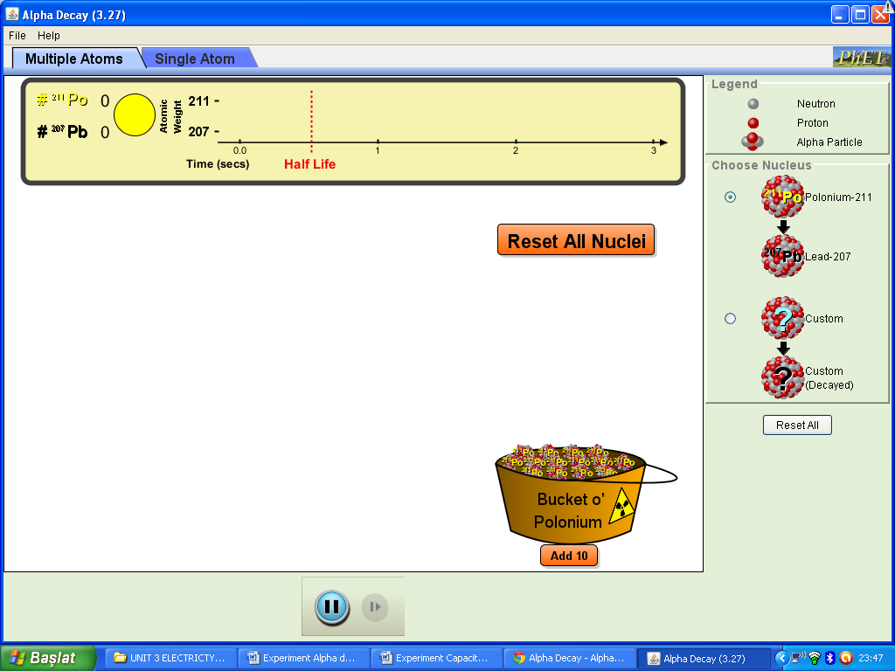
2. Click to “Custom” from the column on the right of the screen and get the below diagram.
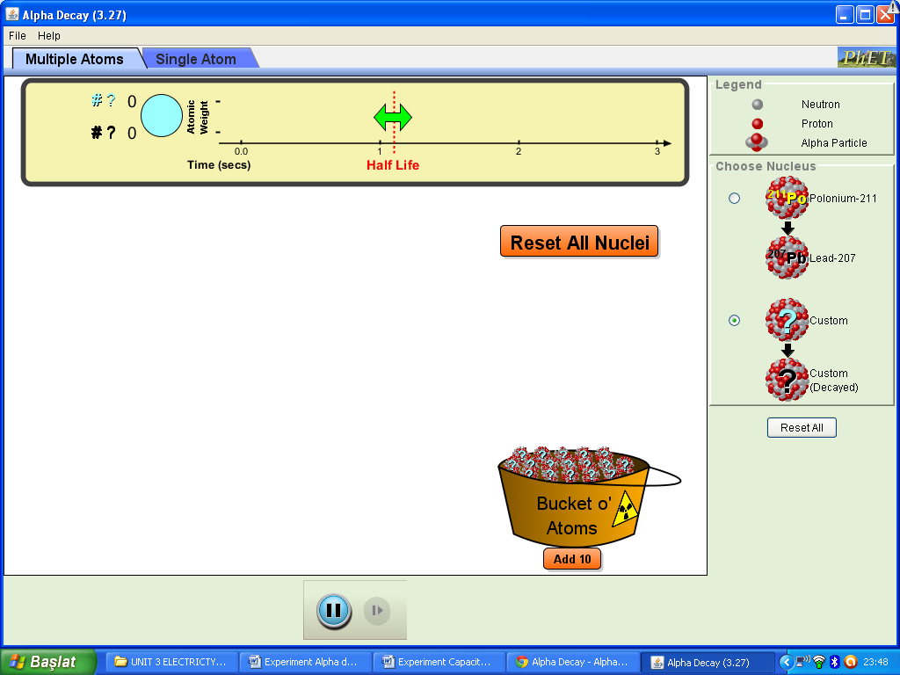
3. Adjust the half life to any value you want between 0.5-1sec. using double-sided green arrow.
4. Add atoms to the bucket by clicking “Add 10” icon below the bucket at the bottom ad get the
below diagram.
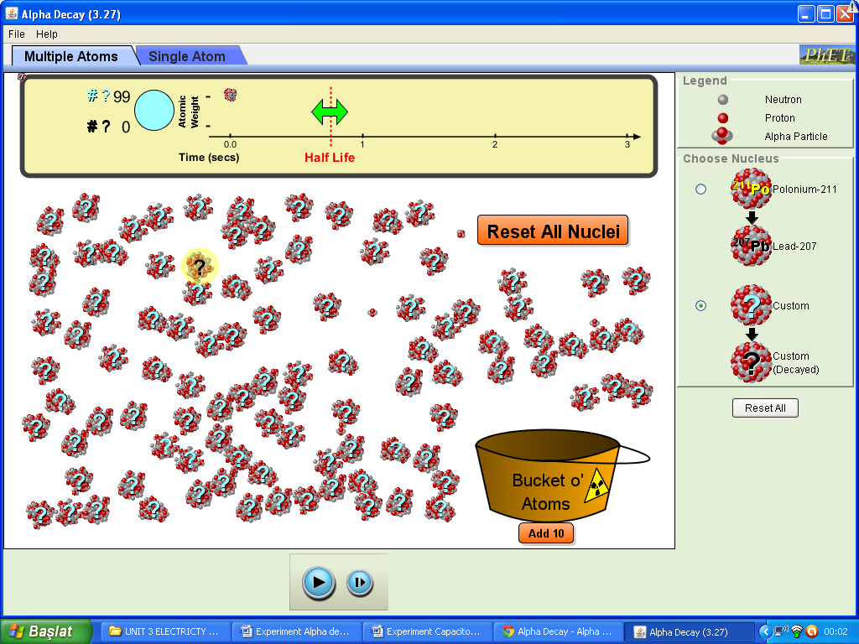

5. By clicking “ ” button, get how many undecayed atom remains in each time interval of 0.5s.
Repeat your measurement 10 times, write your data to the below table and calculate the average.

Time (s) | 0 | 0.5 | 1.0 | 1.5 | 2.0 | 2.5 | 3.0
Number of undecayed atom,N | 99
 | 99
 | 99
 | 99
 | 99
 | 99
 | 99
 | 99
 | 99
 | 99
Average | 99

6. Draw number of undecayed atom vs time graph.

7. Calculate values of ln N (average) and write them in the table below.

Time (s) | 0 | 0.5 | 1.0 | 1.5 | 2.0 | 2.5 | 3.0
Number of  undecayed atom, N | 99
ln N

8. Draw ln N vs time graph and calculate its slope which is known as decay constant,$λ$ .
$$λ= \frac{\ln{N}}{T_{1/2}}$$

9. Using the below relation, calculate half life of parent nucleus.
$$T_{1/2}= \frac{\ln{N}}{λ}$$

