Laboratory simulation: Refraction

Name:________________________________________________________________

**Learning goals**

* Familiarize with simulations of physical processes.
* Log raw data and plot graphs.
* Partially familiarize with the scientific method (phenomenon, prediction, experiment, conclusion).
* Derive the dependence of the angle of refraction on the angle of incidence and the index of refraction.

**Simulation used**

“Refraction of light” (“bending-light_el.jar”)

Additionally: Spreadsheet application (like Microsoft Excel or OpenOffice Calc)

**Theory / Definitions**

1. Optical (or transparent) medium: ________________________________________________________________________

___________________________________________________________________________________________

___________________________________________________________________________________________

___________________________________________________________________________________________

1. Index of refraction: ____________________________________________________________________

___________________________________________________________________________________________

__________________________________________

**4.** Denote the angles of incidence $i$ and refraction $r$.



__________________________________________

__________________________________________

1. Refraction: _________________________________________

_________________________________________

__________________________________________

_________________________________________

___________________________________________________________________________________________

**Experiment 1: Dependence of angle of refraction on the angle of incidence**

Laser light falls from air to a transparent medium.

Prediction: What do we expect to happen to the angle of refraction as the index of refraction of the transparent medium increases? Explain.

___________________________________________________________________________________________

___________________________________________________________________________________________

___________________________________________________________________________________________

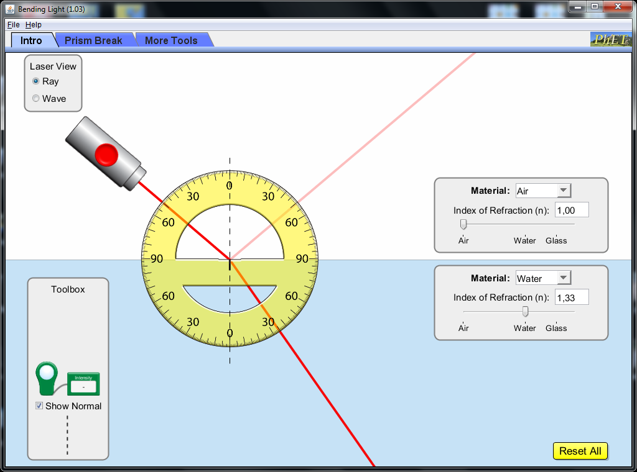

**Set the angle of incidence at ${50}^{ο}$ and leave it unchanged**

**Vary from 1.00 to 1.60**

**Don’t change**

**Measure the angle of refraction $r$**

The laser is placed so that the angle of incidence equals 50 degrees.

**Graph 1: Angle of reflaction vs the index of refraction**

**Table 1: Angle of reflaction vs the index of refraction**



|  |  |  |
| --- | --- | --- |
| Measurement | Index of refraction $n$ | Angle of refraction (degrees) |
| 1 |  |  |
| 2 |  |  |
| 3 |  |  |
| 4 |  |  |
| 5 |  |  |
| 6 |  |  |
| 7 |  |  |

Conclusion compared to our prediction:

___________________________________________________________________________________________

___________________________________________________________________________________________

**Experiment 2: Dependence of the angle of refraction on the angle of incidence**

Predictions/Hypothesis: What do we expect to happen to the angle of refraction as the angle of incidence increases? Explain.

___________________________________________________________________________________________

___________________________________________________________________________________________

___________________________________________________________________________________________



**Keep unchanged**

**Measure the angle of refraction**

**Vary the angle of incidence ($0^{ο} → {90}^{ο}$)**

**Graph 2: Angle of refraction vs angle of incidence**



**Table 2:** **Angle of refraction vs angle of incidence**

|  |  |  |
| --- | --- | --- |
| Measurement | Angle of incidence (degrees) | Angle of refraction (degrees) |
| 1 |  |  |
| 2 |  |  |
| 3 |  |  |
| 4 |  |  |
| 5 |  |  |
| 6 |  |  |
| 7 |  |  |
| 8 |  |  |

Conclusion compared to the prediction:

___________________________________________________________________________________________

___________________________________________________________________________________________

___________________________________________________________________________________________

**Conclusion: Theory predictions versus the results of the 2 experiments.**

A number of scientists between the 10th and the 17th centuries (Sahl, Snellius, Descartes) concluded that the following formula should relate the angle of incidence $i$ with the angle of refraction $r$:

$$sini=\frac{sinr}{n}$$

Explain if the results of the 2 simulated experiments above are compatible with the formula.

Experiment 1:

__________________________________________________________________________________________

__________________________________________________________________________________________

_________________________________________________________________________________________

___________________________________________________________________________________________

___________________________________________________________________________________________

Experiment 2:

___________________________________________________________________________________________

_________________________________________________________________________________________

___________________________________________________________________________________________

___________________________________________________________________________________________

___________________________________________________________________________________________

___________________________________________________________________________________________