Title: Sugar and Salt Solutions
Introduction: In this activity you will investigate changes in concentration using the Sugar and Salt Solutions sim. Concentration is the abundance of a solute (the amount poured) divided by the total volume of a mixture.
- Click this link: http://phet.colorado.edu/
- This is a screen shot of the website:
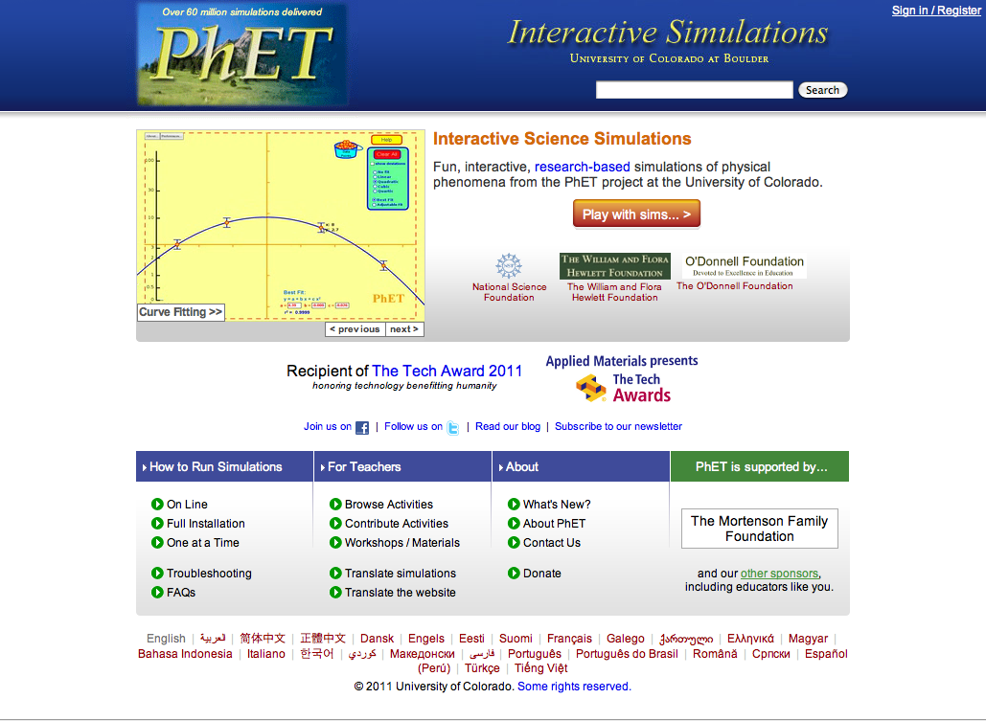
- Click the “Play with sims” button.
- Click “New Sims” -> Click “Sugar and Salt Solutions”->Click “Run Now!”
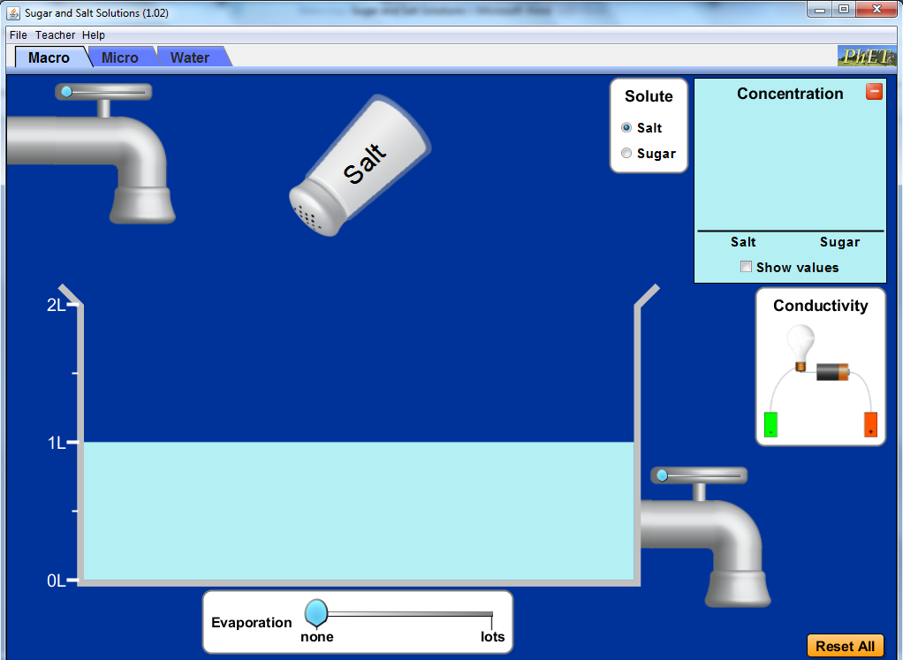
- It may take some time for the sim to load. When it appears it will look like this:

Switch between this document and the sim to complete the activity.
Phase I: Explore
- Select the “Macro” tab on the sim.
- Check the “Show values” box for various measurements to appear.
- Freely explore the sim by creating different solution combinations and concentrations.

TIPS:
*You can empty the shaker by clicking on it and moving it back and forth.*
*A shaker is empty when the color changes from white to gray.*
DO NOT USE ANYTHING IN THE “CONDUCTIVITY” BOX!!!

Please answer the following questions using vocabulary such as increases, decreases, or stays the same. Include any relevant measurements that will provide further details.

- What happens to the volume of water when you move the slider all the way to the right on the faucet on top of the screen?

- What happens to the volume of water when you move the slider all the way to the right on the faucet attached to the tub?

- What happens to the volume of water when you move the evaporation slider to “lots”?

- Is it possible to have 0L of water in the tub? If yes, how?

Phase II: Explain

AIM: How does the amount of water influence the concentration of a solute?

Predict: What will happen to the salt concentration when the amount of water is increased?

- Go back to the sim and select the “Macro” tab on the sim.
- Check the “Show vales” box for various measurements to appear.
- Completely fill the tub with water.
- Pour all of the salt into the tub.
- Record the salt concentration in the table below.

As you work, keep in mind:
Mol is the abbreviation for the word Mole. A mole is a unit of measurement used for an equal number of atoms/ molecules for a substance. For example, 1(one) mole of sugar has the same number of molecules as 1(one) mole of salt.
Amount of Water (L) | Salt Concentration (mol/L)
2.0
1.5
1.0
0.5
0.0
Check your answers with the person sitting next to you.
- Using the information in the table above construct a scatterplot of the amount of water vs. salt concentration. Include it in the space below. (To create a scatterplot using Microsoft Word go to the “Insert” tab -> click “Table” -> click on “Excel Spreadsheet” -> insert the values -> go to the “Insert” tab -> click on “Scatter”.)

- Find patterns in the data and describe any relationships between variables.

- Was your prediction correct? Why or why not?

Phase III: Application
- Go back to the sim and select the “Reset All”.
- Check the “Show vales” box for various measurements to appear.
- Completely fill the tub with water.
- In the “Solute” box choose “Sugar”.
- Pour all of the Sugar into the tub.
- Record the sugar concentration in the table below.

Amount of Water (L) | Sugar Concentration (mol/L)
2.0
1.5
1.0
0.5
0.0
Check your answers with the person sitting next to you.

- Using the information in the table above construct a scatterplot of the amount of water vs. sugar concentration. Include it in the space below. (To create a scatterplot using Microsoft Word go to the “Insert” tab -> click “Table” -> click on “Excel Spreadsheet” -> insert the values -> go to the “Insert” tab -> click on “Scatter”.)

- Find patterns in the data and describe any relationships between variables.

Conclusion: Compare the data in both tables and graphs. Make sure that your response answers the question asked in the AIM.

