Learning objectives: Students will be able to
- connect the importance of inference from experimental data.
- explain the concept of energy absorption and energy emission.
- identify the significance of only specific wavelengths of light being absorbed or emitted.

Prelab questions:
- Describe and draw hydrogen: ( you may want to open Build an Atom PhET for help)

How many protons are there? How many electrons?
- Using resources from the internet, define a photon and find out what determines the color of a photon?

Procedure and analysis:
- 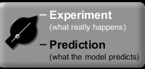Turn the light beam “on.” 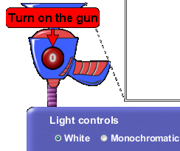 and “Experiment” hi-lighted white. Observe what is happening while photons are being sent through a hydrogen atom. Describe and draw your observations:

- When determining how an atom works, scientists witnessed something similar to what you are witnessing now. They then deduced how the atom must be organized. What do you think is making the photons deflect? What do you observe about how many or what color photons are defected?

- 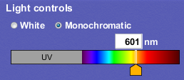Change the Light control from “White” to “Monochromatic”. What does “monochromatic” mean? Make sure to try moving the slider. What is similar and what is different about the photon behavior?

- 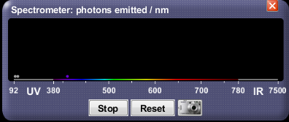Click the “show spectrometer” box. a. Change the colors of the photons to the suggested colors let the simulation run for several minutes then, record observations:
Color | Observation
UV
Purple
Green

b. What is the spectrometer box keeping track of?

Understanding different Models of the Hydrogen Atom:
- 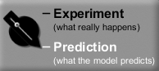Now that you’ve theorized about what is happening to the photons of energy, hi-light the “Prediction” button and observe other scientist’s theories about the atom. When you are working on this section, make comparisons by
- Using a wavelength of 97 nm and white light.
- Use “experiment” and “predictions”.
- Use the spectrometer and observations about photons

Complete the chart below by comparing the 6 models with the experiment (what is really happening) and try to explain why the model does/does not explain the experimental observations.

Atomic Model | Observations | How does it support or not support the experiment?
Billiard Ball
Plum Pudding
Classical Solar System
Bohr
De Broglie
Schrodinger

- With the Bohr’s model selected, click the “Show electron energy level diagram.”
Using the Electron Energy Level Diagram and the spectrometer, describe what is happening to hydrogen’s one electron.

- In the help menu, click on transitions. Enter the first 5 wavelengths into the wavelength box and observe what happens to the electron. Does this support your ideas in #2? If not, readjust your statement to explain you new ideas about the behavior of the electron.

- Now enter wavelengths that are not listed. What do you observe? Does this support your ideas? If not, readjust your statement to explain the new behavior of the electron.

