Intro to Energy Model PhET Lab Name ________________________ Hr __

In this lab, you will analyze energy transfer between gravitational potential energy, kinetic energy, and dissipated energy (thermal energy in this sim) as a skate boarder rides inside a half-pipe.

Pre-Lab
Define the following:
- Gravitational Potential Energy (E_{g})

- Kinetic Energy (E_{k})

- Dissipated Energy (E_{diss})

Part A – No Friction
- Open the Energy Skate Park Basics PhET simulation as instructed in class.
- Check the Bar Graph option on the right of the simulation.
- Click on the skateboarder, place him on the track at the top of the half-pipe, and let him go. Click the slow-motion option at the bottom to make things easier to follow.
- As the skateboarder rides back and forth…
  - Describe how the potential energy changes.

  - Describe how the kinetic energy changes.

  - Describe how the total energy changes.

- Now click the Pie Chart option on the right of the simulation and observe the pie chart as the skateboarder rides back and forth.
  - What does the total size of the pie represent?

- Now check the Grid option on the right of the simulation. As the height of the skateboarder changes…
  - Describe how the potential energy changes.

  - Describe how the kinetic energy changes.

- Now check the Speed option on the right of the simulation and observe the speedometer. As the speed changes…
  - Describe how the potential energy changes.

  - Describe how the kinetic energy changes.

Part B – Friction
- Now click the Friction tab at the top of the simulation.
- Check the bar graph option and pie chart option on the right of the simulation.
- Turn friction on and set the slider bar for the friction amount at roughly 25%.
- Click the slow-motion option at the bottom to make things easier to follow.
- Place the skateboarder on the track at the top of the half-pipe and let him go.
- As the skateboarder rides back and forth…
  - Describe how the potential energy changes.

  - Describe how the kinetic energy changes.

  - Describe how the thermal energy (dissipated energy) changes.

  - Describe how the total energy changes.

- After the skateboarder comes to a stop, turn on the Grid and Speed options on the right of the simulation.
- Place the skateboarder on the track at the top of the half-pipe and let him go again.
- As the skateboarder rides back and forth…
  - Describe how the maximum velocity changes.

  - Describe how the maximum height changes.

Part C – Track Playground Ranking Tasks (friction turned off)
Do the ranking tasks below assuming no friction. Use the Track Playground tab for help.
.
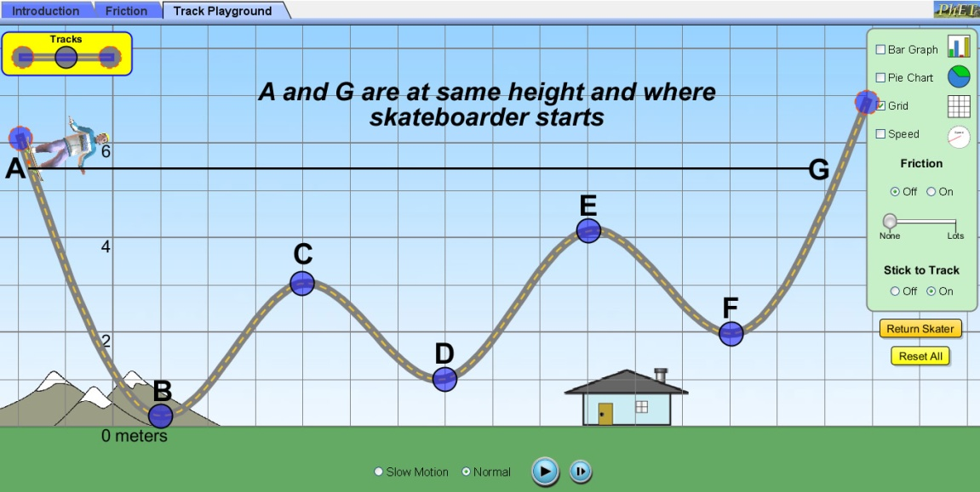
- Rank the skateboarder positions A – G above in order of greatest potential energy to least potential energy. Ties are possible.
___ ___ ___ ___ ___ ___ ___

- Rank the skateboarder positions A – G above in order of greatest kinetic energy to least kinetic energy. Ties are possible.
___ ___ ___ ___ ___ ___ ___

