Molarity Remote Lab
(This‌ ‌lesson‌ is designed ‌for‌ ‌a‌ ‌student‌ ‌working‌ remotely‌.)‌
This lab uses the Molarity simulation from PhET Interactive Simulations at University of Colorado Boulder, under the CC-BY 4.0 license.
https://phet.colorado.edu/sims/html/molarity/latest/molarity_en.html

Learning Goals: Students will be able to
- Determine the solubility for some solutes and explain why the solubility cannot be determined for others given experimental constraints.
- Identify the relationships for measurable variables by designing quantitative experiments, collecting data, graphing, and using appropriate trend lines.

Everyday Chemistry in your life:
- If you were dissolving salt or sugar in some water, how would you know it was a saturated solution?

- Describe experiments that would demonstrate some saturated solutions and some unsaturated solutions.

Develop your understanding:
- Use Molarity simulation to test your ideas about saturated and unsaturated solutions.
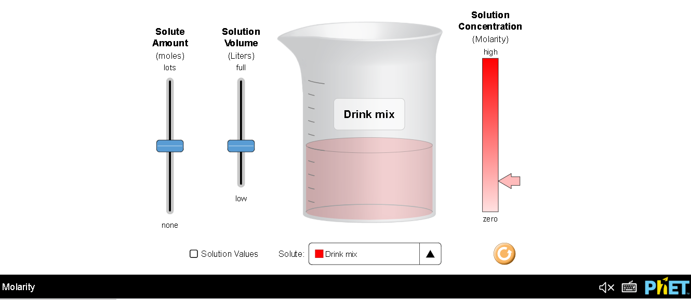

Explain your understanding:
- Make a list of all the solutes and determine the solubility if possible.

  - Explain how you know you have identified the solubility.
  - Explain why you couldn’t determine the solubility for some substances. How does this explanation match your experimental ideas for question #2?
- What are the variables for solutions in this simulation? Which are independent and which are dependent?

Design experiments to find relationships:
- Design an experiment to determine the relationship between one of the independent variables and the dependent one. Collect data for more than one solute so that you will have more than one trend line to support your conclusion about the relationship.
  - Google sheet hint: To graph more than one set of data and make multiple trendlines. First make sure that the independent variable values are consistent; put them in the A column. Then, you can put the dependent results in other columns. (If you are not familiar with adding trendlines to sheet charts, some research may be needed.)
  - For example, a student designed an experiment to determine the speed of three toy cars at the bottom of a ramp released from a variety of heights. Their data table and graph with trendlines looked like this:

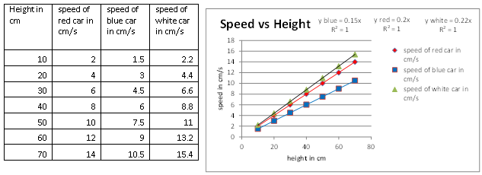

- Design another experiment to determine the relationship between the other independent variable and the dependent one. Collect data for more than one solute so that you will have more than one trend line to support your conclusion about the relationship.Include your table and chart with trendlines.

Test your understanding and self check: For each question, support your answer with an explanation. You may use the Molarity simulation to verify and add screen captures to your explanation.
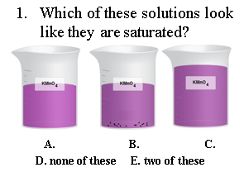
- Answer and explanation with support

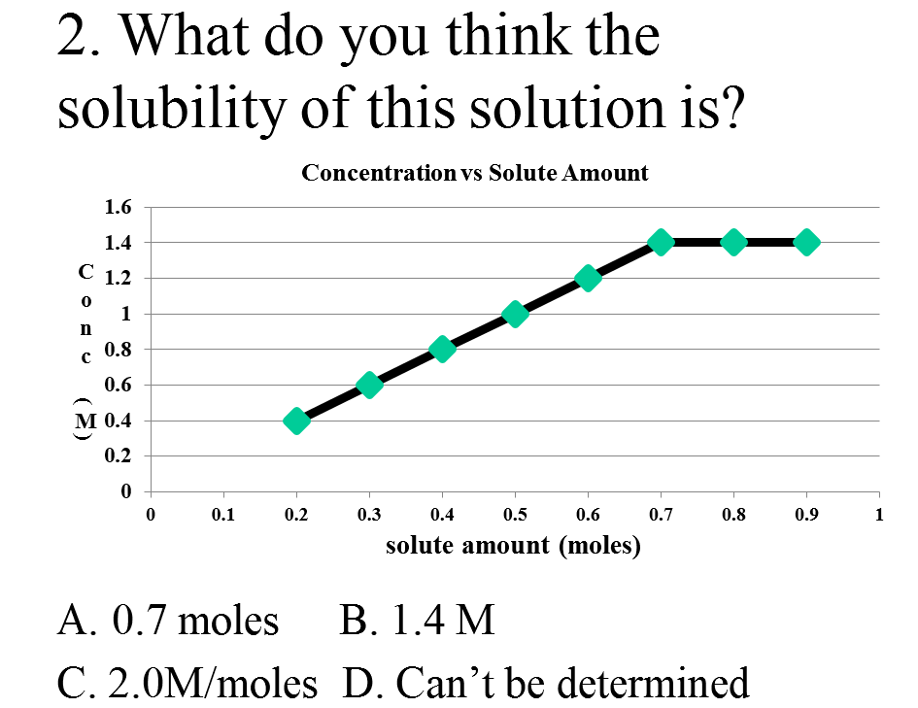
- Answer and explanation with support

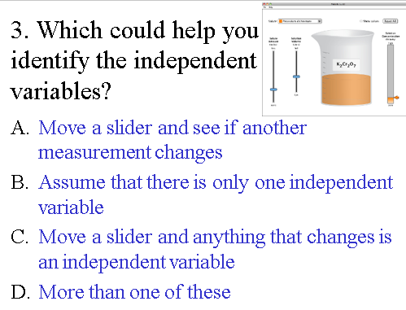
- Answer and explanation with support

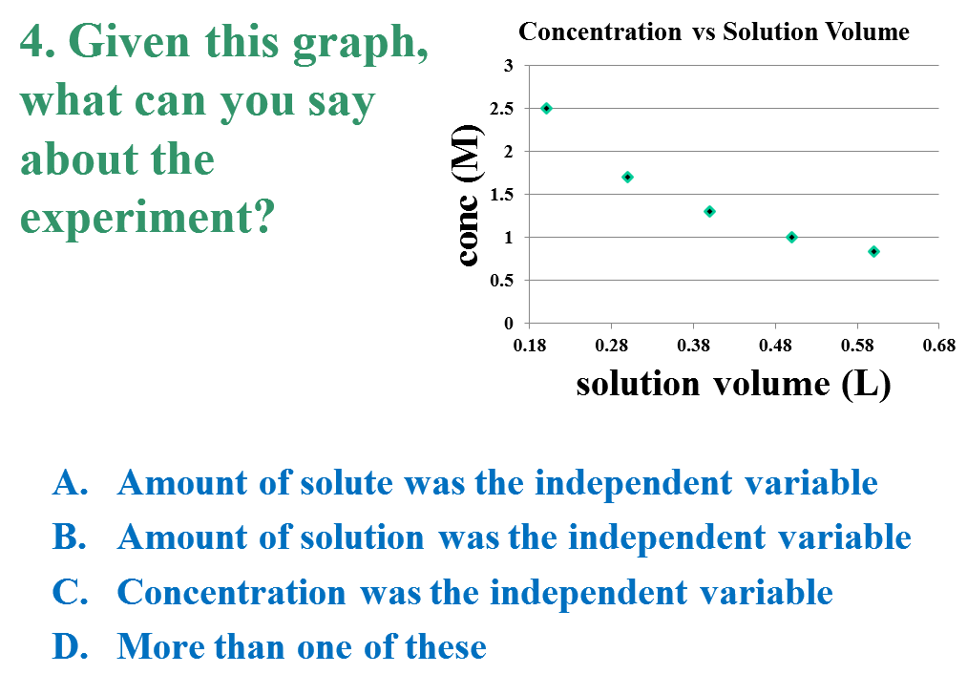
- Answer and explanation with support

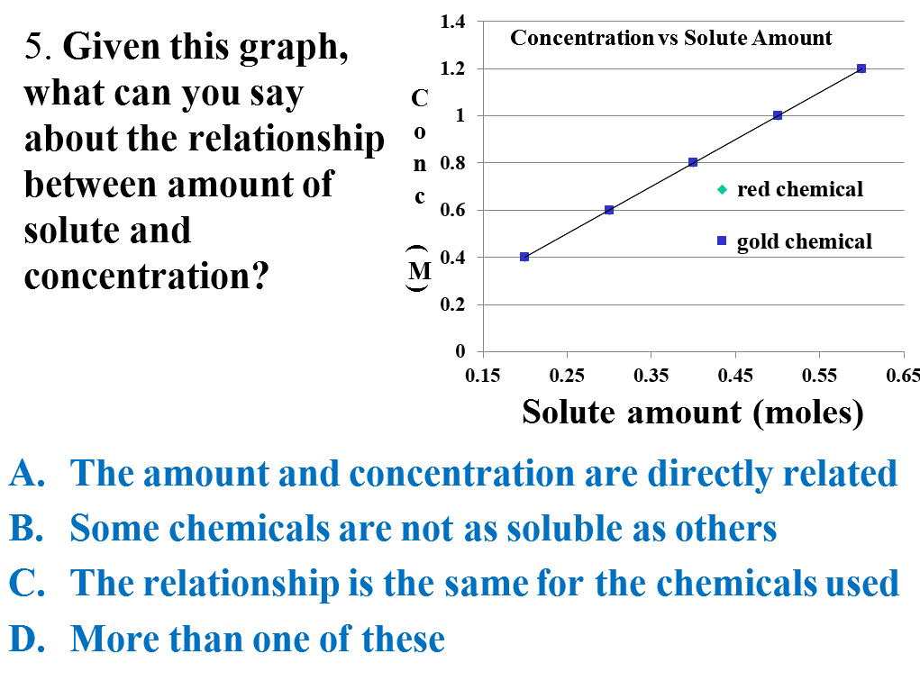
- Answer and explanation with support

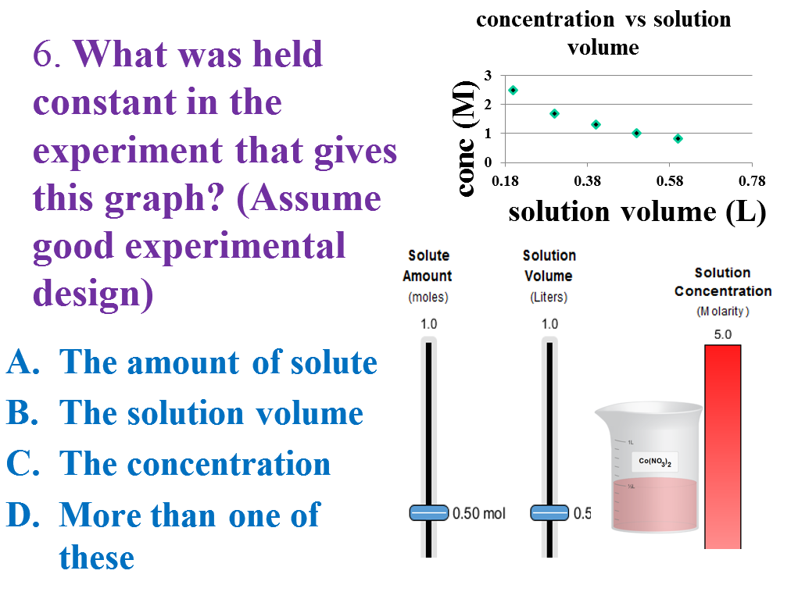
- Answer and explanation with support

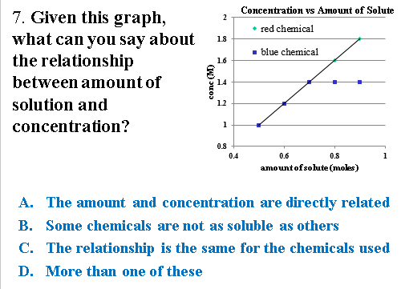
- Answer and explanation with support

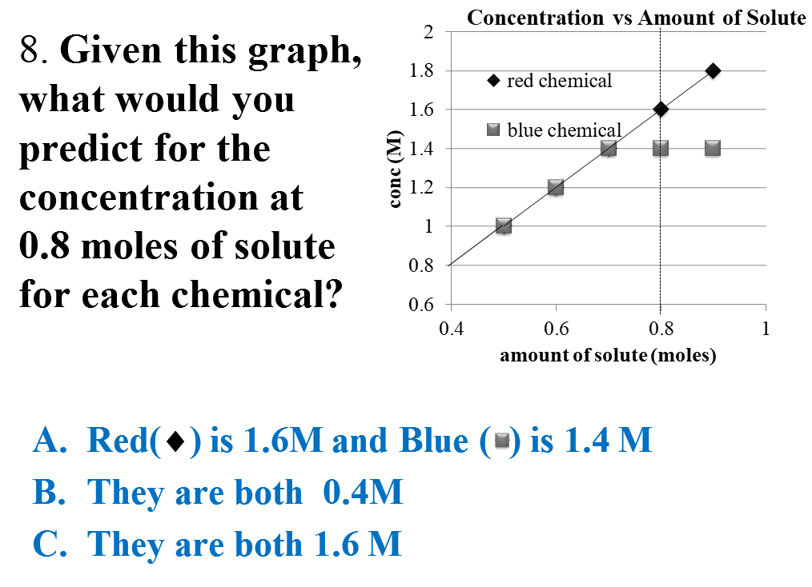
- Answer and explanation with support

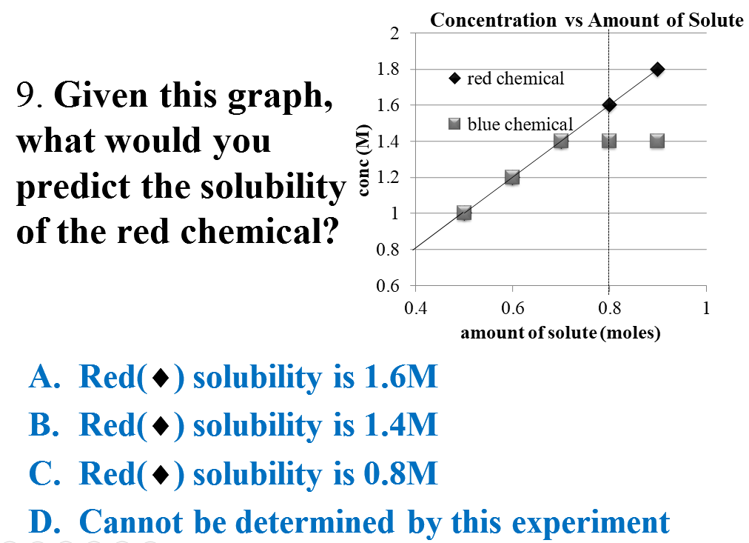
- Answer and explanation with support

Optional next lab: Concentration_Molarity_Remote_Lab by Loeblein

