Molecular Shapes Lab Name:

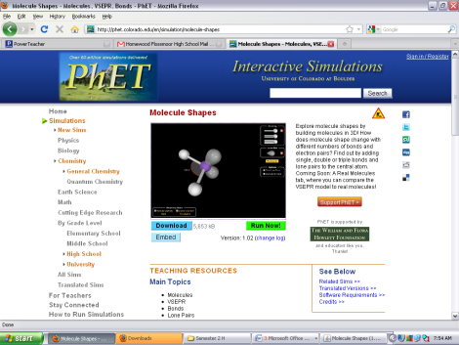
Purpose: You will use a 3D computer simulator to determine patterns in molecular geometry and electron geometry. By the end of this lab, you should be able to determine the shape of a basic molecule based on the bonds and electron pairs surrounding the central atom.

Step 1: Go to http://phet.colorado.edu/en/simulation/molecule-shapes
(or Google “phet molecular shapes”)
Step 2: Run the simulator
Step 3: Check “Molecule Geometry” and “Electron Geometry”
Step 4: Create the molecules listed below by adding and removing
single-bonded atoms and electron clouds.

Single Bond | Lone Pairs | Molecule Geometry | Electron Geometry | Bond Angle | Sketch
0 | 1
0 | 2
0 | 3
0 | 4
0 | 5
0 | 6
1 | 0
1 | 1
1 | 2
1 | 3
1 | 4
1 | 5
2 | 0
2 | 1
2 | 2
2 | 3
2 | 4

Single Bond | Electron Cloud | Molecule Geometry | Electron Geometry | Bond Angle | Sketch
3 | 0
3 | 1
3 | 2
3 | 3
4 | 0
4 | 1
4 | 2
5 | 0
5 | 1
6 | 0

Questions:
What is the difference between “Molecule Geometry” and “Electron Geometry”?

What general patterns exist for identifying the Molecule Geometry of a molecule?

What general patterns exist for identifying the Electron Geometry of a molecule?

On a separate sheet of paper, create a simplified chart that you could use to identify the shape of a molecule based on the number and type of bonds surrounding the central atom.

