Learning Goals: Students will be able to:
- Describe differences and similarities between solids, liquids and gases on a molecular level.
- Explain gas pressure using the Kinetic Theory.
- Determine processes you could use to make solids, liquids and gases change phases.
- Compare and contrast the behavior of the 4 substances in the simulation and use your understanding about molecules to explain your observations.

Background:
Most chemistry students did activities and saw demos using Gas Properties and States of Matter last year in Physics (see activity https://phet.colorado.edu/en/contributions/view/2816) to help them construct and understanding of KMT, but not much about pressure. We also studied Thermodynamics. In chemistry, we have already had an introduction to bonding but not about its application to macroscopic behavior. This lesson focuses on introducing the effect of pressure and also comparing materials that have Van der Waals bonding and polar bonding. I would be surprised if the students use the proper explanations for the varying affects from their investigations and plan to use the Clicker questions to help them especially with goals 3 and 4. I also plan to discuss Phase diagrams in the post discussion. Other simulations that could be used as extension exploration for this topic: States of Matter and Atomic Interactions .

States of Matter Basics Teaching tips: The sim has Ne Ar O₂ and H₂O (the other version also has a Custom particle that you can adjust the inter-particle attraction and a tab to study particle attraction). Basically, the students should be able to see that the larger Ar has more Dispersion forces and that O₂ has even more. Then they can explore varying the force of attraction which varies from very low London Dispersion (Van Der Waals) to just below the strength of the water dipole force.

Lesson: My students work in pairs at computers or at home on their own depending on computer availability. If we are working in class, I check on their progress by looking at some answers and I am available for questions. Few of my students use the proper explanations for the varying affects from their investigations and plan to use the Clicker questions to help them especially with goals 3 and 4. I also plan to discuss Phase diagrams in the post discussion.

Post lesson:
Other simulations for this topic: States of Matter and Atomic Interactions .
Sample slides to use for the post-lesson: (all of the slides may be downloaded in Powerpoint or Acrobat Reader from http://phet.colorado.edu/en/contributions/view/3496 )

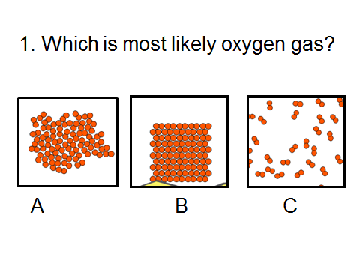 | 