Build an Atom Remote ‌Lab ‌
(This‌ ‌lesson‌ is designed ‌for‌ ‌a‌ ‌student‌ ‌working‌ remotely‌.)‌

This lab uses the Build an Atom simulation from PhET Interactive Simulations at University of Colorado Boulder, under the CC-BY 4.0 license.
https://phet.colorado.edu/sims/html/build-an-atom/latest/build-an-atom_en.html

Learning Goals: Students will be able to
- Make atom models that show stable atoms or ions.
- Use given information about subatomic particles to
- Identify an element and its position on the periodic table
- Draw models of atoms
- Determine if the model is for a neutral atom or an ion.
- Predict how addition or subtraction of a proton, neutron, or electron will change the element, the charge, and the mass of their atom or ion.
- Describe all vocabulary words needed to meet the goals.
- Use a periodic symbol to tell the number of protons, neutrons, and electrons in an atom or ion.
- Draw the symbol for the element as you would see on the periodic table

Part 1 Directions: Use your own words and captured images for each question.

Develop your understanding: Open the Atom screen, then explore to develop your own ideas about the atomic particles that make up atoms and ions.

Explain your understanding:

- What parts go in the center of the atom? What is the center called?

- Explore until you discover a good rule for making the center of the atom stable.
  - What seems to make the center of the atom unstable?

  - Fill in the table to identify three examples – at least 1 stable and at least 1 unstable – that shows your rules for stability work to “build an atom” of your own.

 | What is in your nucleus? | Capture and paste your atom | Is it stable or unstable? | What Element is it?
1
2
3

Develop your understanding: Explore to develop your own ideas about what makes an atom and how ions are different from atoms.

Explain your understanding:
- What are some good rules about the charge of your atom or ion?

  - What is a rule for making a neutral atom which has no charge?

  - What is a rule for making a positive ion which has positive charge?

  - What is a rule for making a negative ion which has negative charge?

  - How did you use the tools in the sim that helped you decide if the atom had a positive, negative, or 0 charge?

  - Make a table like the one below to identify three examples of stable atoms and ions. Include 1 with neutral charge, 1 with a positive charge, and 1 with a negative charge .

 | What is in your  atom or ion?  (Stable only) | Capture and paste your atom or ion | What is  the charge? | Is it a neutral atom, positive ion,  or negative ion? explain why
1 | # of protons:  # of neutrons:  # of electrons:
2 | # of protons:  # of neutrons:  # of electrons:
3 | # of protons:  # of neutrons:  # of electrons:

Understanding Mass
- Explore until you can explain some good rules about the mass of your atom or ion. Then design a way to test your ideas and demonstrate that your rules work. Remember to include evidence of screen captures.

Part 2 Use your own words and captured images for each question.

Develop your understanding: Everything around us is made up of different elements. The air has Oxygen and Nitrogen. Plants and people have lots of Carbon. Helium is in balloons. Hydrogen is in water.
Open the Symbol screen, then explore to develop your own ideas about how the atomic particles determine the name of an atom or ion.

Explain your understanding:

- What determines the element?

- Test your idea by identifying the element for the 3 cases.Insert captured images.
example | Atom or Ion has | What Element is it?
1 | # of protons: 6  # of neutrons: 6  # of electrons: 6
2 | # of protons: 7  # of neutrons: 6  # of electrons: 6
3 | # of protons: 6  # of neutrons: 7  # of electrons: 7

- What does the tool called Symbol tell you about what parts are in an atom or ion?

- What rules can you use to tell how many protons, neutrons and electrons make up an atom or ion?

Test your understanding: Open the full simulation Build an Atom

- Using all of the rules you have determined, figure out what changes for each of these changes to an atom or ion. If you have new ideas, go back and rewrite your rules.

Make the change: | What changes also? Element name, charge, mass?
Add a Add a proton
RRem Remove a neutron
Remove an electron
Add an electron

Make sure you know working definitions for each of the vocabulary words for Build an Atom. You might research online resources to check your understanding; but cite any references that you use. Here are the words:
nucleus, proton, neutron, electron, atom, ion, charge, neutral, atomic mass, and element.

Part 3 Test your understanding and use the rules you wrote to play a game.
- Play Level 1of the Build an Atom game
  - Did you have to change your rules or do you have other ideas to make you get a better score? Include screen captures from the simulation to help explain.

  - When you complete the level 1 game, capture the screen with your score. Paste it below like this: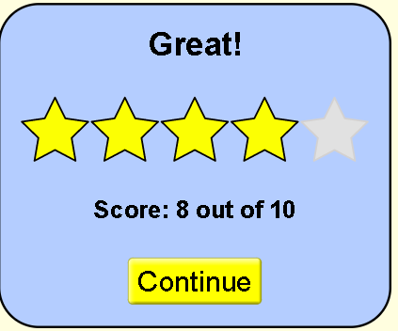
- Play Level 2 of the game
  - Explain what makes the level more difficult or different from previous levels. Do you have new strategy ideas or rules? Include screen captures from the simulation to help explain.

  - When you complete the level, capture the screen with your score and paste it below:

- Play Level 3 of the game
  - Explain what makes the level more difficult or different from previous levels. Do you have new strategy ideas or rules? Include screen captures from the simulation to help explain.

  - When you complete the level, capture the screen with your score and paste it below:

- Play Level 4 of the game
  - Explain what makes the level more difficult or different from previous levels. Do you have new strategy ideas or rules? Include screen captures from the simulation to help explain.

  - When you complete the level, capture the screen with your score and paste it below:

Final Score:
After you play all levels of the game. Copy and paste your final results like this
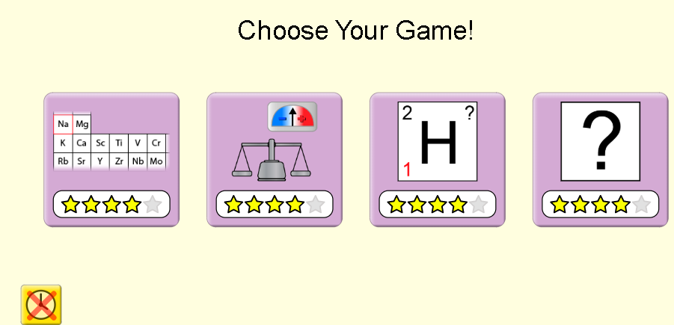
Extra challenge: For an extra challenge, you can turn on the timer and see if you can improve your skills.

