**Name: ___­­­­­­­­­__________________________  
Grade: _____________________________**

**Static**

**Pre-Lab:**

1. When you pull clothes out of the dryer, sometimes they stick together.   
   What do you think might explain why they stick?
2. What do you think happens in the dryer that makes the clothes stick together?
3. The pictures below show positive and negative circles.   
   The **negatives are stuck in place**, but the **positive is free to move**:

  

**A B C**

1. For each picture **above**, **draw arrows** on the positive circle ( ) to show which way you think it will move.
2. In which picture **below,** do you think the positive circle would go the **fastest**? (Circle your answer)

  

**A B C**

**Why?**

__________________________________________________________________________

__________________________________________________________________________

1. In the pictures below, the middle positive “pucks” are free to move, and have some positive and negative circles are stuck down on either side of them.

For each case (A, B, and C), **do you think the middle positive “puck” will move or not move?**

If the puck will move, **draw an arrow** on the “puck” to show which way you think it will move.

If the puck won’t move, write that down.



**Teacher Notes for Static**

**Learning Objectives:**

* Students will be able to determine the variables that affect how positive and negative objects interact.
* Students will be able to predict how positive and negative objects will interact.

After pre-lab, the teacher will facilitate demo with balloons. Students/teachers will rub them on their hair and see their hair stick to balloons. See them stick to the wall. Tie a couple of balloons together and see them repel.

Equipment:   
Balloons

String

Sharpie Pen (to mark on balloon so can keep track of section you’ve charged.)

Facilitate generation of a class list of observations (not reasons) … just observations …

* Like hair sticks to the balloons after rubbing.
* Balloons repel one another

Then tell students that they will be exploring how this happens today in our activity. Then onto 1st question where students discuss as partners.

**Name: ___­­­­­­­­­__________________________**

**Static**

**Learning Objectives:**

* Students will be able to determine the variables that affect how positive and negative objects interact.
* Students will be able to predict how positive and negative objects will interact.

1. You and the class just made some observations with balloons – sticking and repelling.

Discuss with your partner your ideas about **why** the balloons would stick to things (like hair) after rubbing on your head? And repel from each other?

**Use words and pictures to describe your ideas** about what might be going on.

______________________________________ ______________________________________   
______________________________________   
______________________________________

______________________________________

2. Let’s look at the **Balloons and Static Electricity simulation**.

1. Explore the simulation.   
   How can you make the balloon stick to the sweater?   
   __________________________________________________________________________________________________________________________________________________________  
   What makes it stick weakly versus strongly?

__________________________________________________________________________________________________________________________________________________________

1. How do the plus or minus symbols help you decide whether something attracts or repels?

__________________________________________________________________________________________________________________________________________________________

1. Talk about how your observations support, change or add to your ideas from Question 1 and about what affects whether things attract or repel. Then **revise your ideas from Question 1**.

3. With you partner, test your ideas about attraction and repulsion using the **Electric Field Hockey** simulation in the **Practice mode**.

Play with the sim and talk with your partner about ideas that help you SCORE!

Now, develop strategies for the following challenges:

|  |  |
| --- | --- |
| Make a GOAL where puck takes the  **SHORTEST amount of time** to get to the goal | Make a GOAL where puck takes the  **LONGEST amount of time** to get to the goal |
| **Draw your strategy** for placing  positives or negatives  in the picture below.    What **rules** are you using to determine  **which direction** the puck moves?  _______________________________  _______________________________  _______________________________  _______________________________  What **rules** are you using to determine  **how fast** the puck moves?  _______________________________  _______________________________  _______________________________  _______________________________  _______________________________ | **Draw your strategy** for placing  positive or negative pucks  in the picture below  What **rules** are you using to determine  **which direction** the puck moves?  _______________________________  _______________________________  _______________________________  _______________________________  What **rules** are you using to determine  **how fast** the puck moves?  _______________________________  _______________________________  _______________________________  _______________________________  _______________________________ |
|  |  |

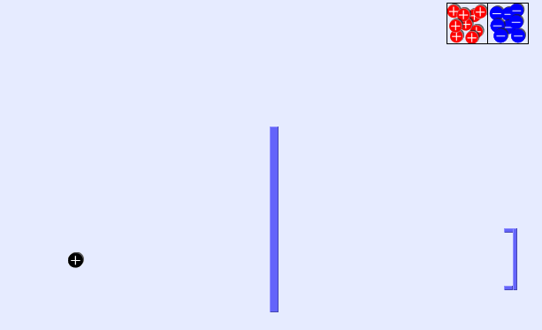4. **Draw** where you might put pucks to get a goal with the **fewest pucks.**

**Explain why this works:**____________________

____________________

____________________

____________________

____________________

____________________

5. Reflect on your ideas from Questions 1&2 and your data from Questions 3&4. How do your observations support, change or **add** to your ideas about…

**…whether two objects will attract and repel?**

**…how strongly they attract or repel?**

**Revise your explanation from Question 1.**

**Name: ___­­­­­­­­­__________________________**

**Static**

**Post-Lab:**

1. When you pull clothes out of the dryer, sometimes they stick together.   
   What do you think might explain why they stick?
2. What do you think happens in the dryer that makes the clothes stick together?
3. The pictures below show positive and negative circles.   
   The **negatives are stuck in place**, but the **positive is free to move**:

  

**A B C**

1. For each picture **above**, **draw arrows** on the positive circle ( ) to show which way you think it will move.
2. In which picture **below,** do you think the positive circle would go the **fastest**? (Circle your answer)

  

**A B C**

**Why?**

__________________________________________________________________________

__________________________________________________________________________

1. In the pictures below, the middle positive “pucks” are free to move, and have some positive and negative circles are stuck down on either side of them.

For each case (A, B, and C), **do you think the middle positive “puck” will move or not move?**

If the puck will move, **draw an arrow** on the “puck” to show which way you think it will move.

If the puck won’t move, write that down.



1. Moving balloons?

In the picture below, the balloons on the left and middle are held in place. The right balloon is free to move.

Is it possible to add positives or negatives on the free balloon that would make it **move   
to the left ( 🡨 )**? ­­­­­___________

If so, then **draw** positives or negatives on the balloon that would make it move, and explain why you think it would work? ­­­­­­­­­__________________________________________________________ _______________________________________________________________________________ ______________________________________________________________________________

If is not possible, explain why? ­­­­­­­­­­­­­­­­______________________________________________________



1. How ***useful for your learning*** was this science activity, compared to other science class activities? (circle)

More useful About the same Less useful

How ***enjoyable*** was this science class activity, compared to other science class activities? (circle)

More enjoyable About the same Less enjoyable

Why did you or did you not find it useful or enjoyable? ____________________________________________________________________________________________________________________________________________________________________________________________________________________________________________________________________________________________________________________________