Balancing Chemical Equations Remote Lab
(This‌ ‌lesson‌ is designed ‌for‌ ‌a‌ ‌student‌ ‌working‌ remotely‌.)‌

This lab uses the Balancing Chemical Equations simulation from PhET Interactive Simulations at University of Colorado Boulder, under the CC-BY 4.0 license.
https://phet.colorado.edu/sims/html/balancing-chemical-equations/latest/balancing-chemical-equations_en.html
Learning Goals: Students will be able to:
- Describe what “reactants” and “products” in a chemical equation mean.
- Explain the importance of knowing the difference between “coefficients” and “subscripts”.
- Use pictures and calculations to show how the number of atoms for each product or reactant is found.
- Identify the relationship between “reactants” and “products” atoms.
- Balance a chemical equation using the relationships identified.
- Given a chemical equation, draw molecular representations of the reaction and explain how the representations were derived.
- Given a molecular drawing of a chemical reaction, write the equation and explain how the symbols were derived.
Develop your understanding: Open the Introduction screen, then explore to develop your own ideas about what it means to “balance a chemical equation”.
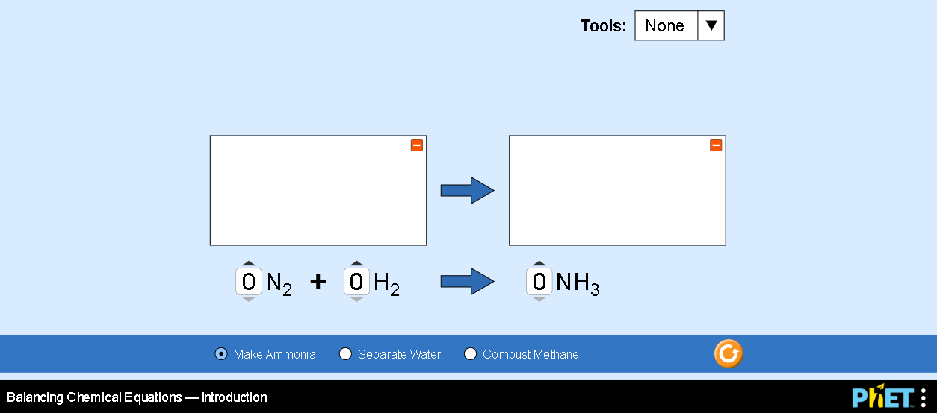

Explain your understanding:

- How does the sim provide information to help you learn the goals?

- What things did you have to research outside the sim (cite references)?

- How can you use the simulation to check your learning?

- Use this balanced reaction to show that you can write the equation that makes chemical sense. Explain how your symbols were derived in paragraph form.

- Use this reaction to show that you can draw molecular representations of a balanced reaction. Explain how your representations were derived in paragraph form.
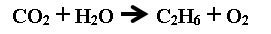
Test your understanding: For each question, write your answer and give your reasoning with evidence from the simulation.

Question 1
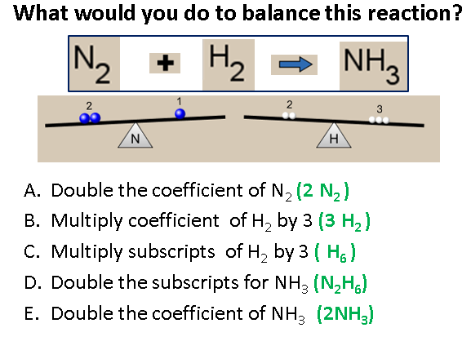
Your answer and explanation:

Question 2
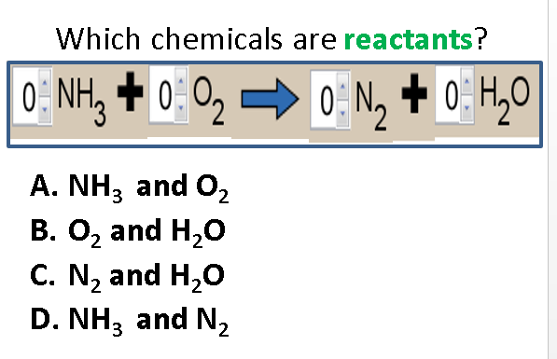
Your answer and explanation:

Question 3
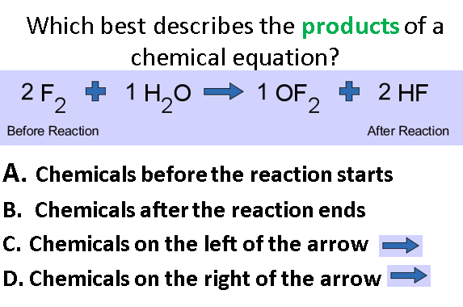
Your answer and explanation:

Question 4
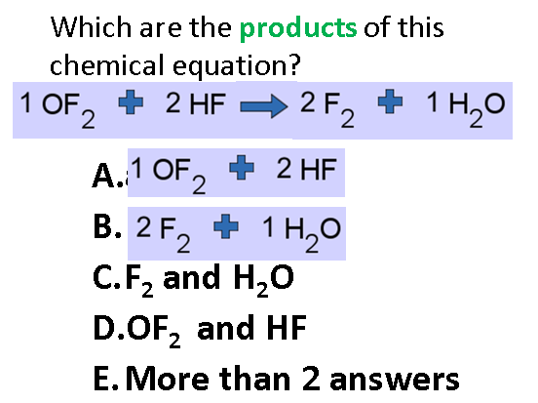
Your answer and explanation:

Question 5
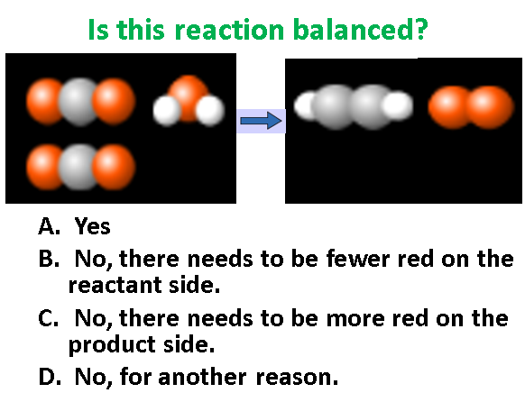
Your answer and explanation:

Test your understanding and skill application:
Open the full simulation Balancing Chemical Equations, then open the Game screen. Use ideas you have from the learning goals. You may need to use the Intro and Balance Lab screens to learn.

- Play Level 1of the Balancing Chemical Equations game
  - Did you have to change your thinking or do you have other ideas to make you get a better score? Include screen captures from the simulation to help explain.

  - When you get a wrong answer, how did the “Show Why” help you?

  - When you complete the level 1 game, capture the screen with your score. Paste it below like this: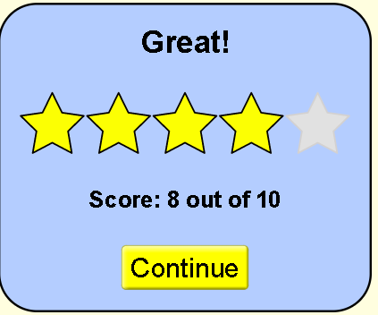
- Play Level 2 of the game
  - Explain what makes the level more difficult or different from previous levels. Do you have new strategy ideas or rules? Include screen captures from the simulation to help explain.

  - When you complete the level, capture the screen with your score and paste it below:

- Play Level 3 of the game
  - Explain what makes the level more difficult or different from previous levels. Do you have new strategy ideas or rules? Include screen captures from the simulation to help explain.

  - When you get a wrong answer, how did the “Show Why” help you?

  - When you complete the level, capture the screen with your score and paste it below:

Final Score:
After you play all levels of the game. Copy and paste your final results like this
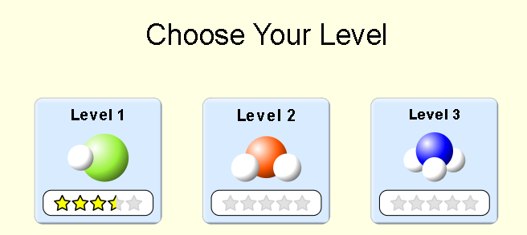
Extra challenge: For an extra challenge, you can turn on the timer and see if you can improve your skills.

