Isotopes‌ ‌and‌ ‌Atomic‌ ‌Mass‌‌ ‌Lab ‌
(This‌ ‌lesson‌ is designed ‌for‌ ‌a‌ ‌student‌ ‌working‌ remotely‌.)‌

This lab uses the Isotopes and Atomic Mass simulation from PhET Interactive Simulations at University of Colorado Boulder, under the CC-BY 4.0 license.
https://phet.colorado.edu/sims/html/isotopes-and-atomic-mass/latest/isotopes-and-atomic-mass_en.html

Learning Goals: Students will be able to:
- Define “isotope” using mass number, atomic number, number of protons, neutrons and electrons.
- Compare and contrast: element, atom, isotope
- Given the number of protons, neutrons and electrons, find the mass and name of an isotope
- Given the name of an element and the number of neutrons, find the mass of an isotope
- Give evidence to support or dispute: “In nature, the chance of finding one isotope of an element is the same for all elements.”
- Find the average atomic mass of an element given the abundance and mass of its isotopes

Develop your understanding: Open the Isotopes screen, then explore to develop your own ideas about “isotopes”.
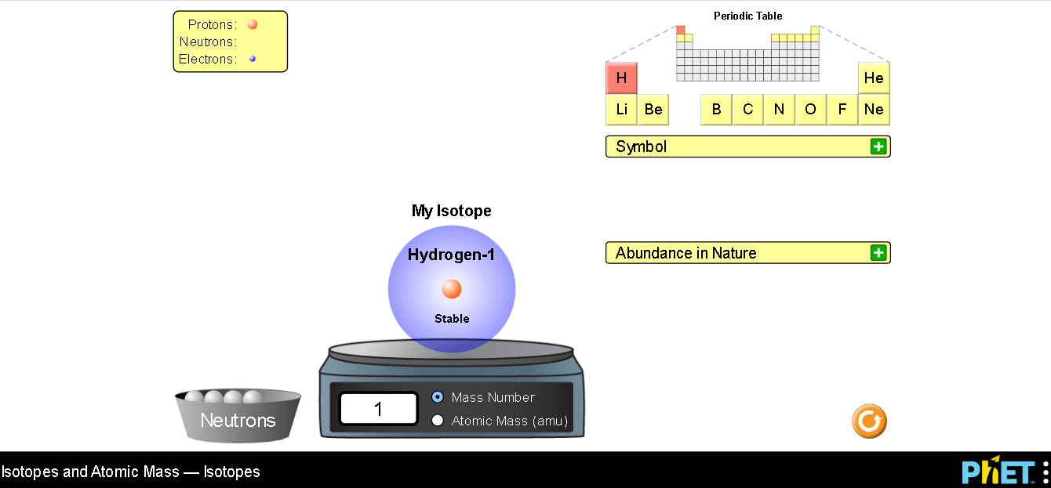

Explain your understanding: Use your own words and captured images from the simulation to show you can:
- Define “isotope” using mass number, atomic number, number of protons, neutrons and electrons.

- Compare and contrast: element, atom, isotope

- Given the number of protons, neutrons and electrons, find the mass and name of an isotope

- Given the name of an element and the number of neutrons, find the mass of an isotope

Develop your understanding: Explore the Mixtures screen to develop your ideas about isotope mixtures are related to Average Atomic Mass. Make sure to explore both My Mix and Nature’s Mix

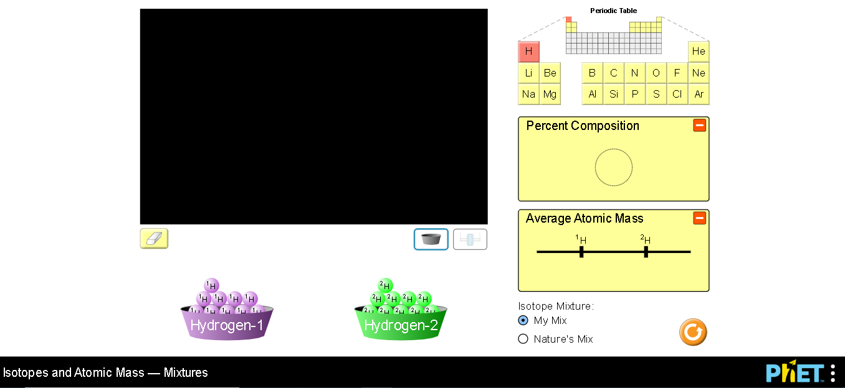

Explain your understanding:

- What are the differences between My Mix and Nature’s Mix? Include screen captures in your explanation.

- Give evidence to support or dispute: “In nature, the chance of finding one isotope of an element is the same for all elements.” use the sim and cite references to write a paragraph for your argument.

Test your understanding:
Open the full simulation Isotopes and Atomic Mass

- You and your friend, Bill, are given a rock that you know has some Silicon. You just learned that there are 3 common isotopes of silicon- Silicon-28, Silicon-29, and Silicon-30. Bill suggests that the rock might have equal parts of each isotope.
- What would be the average mass of Silicon in the rock? Capture your screen from the sim to show a solution that would support Bill’s idea.

- How could you check to see if Bill’s ideas are correct?

- Iron has many isotopes but only 4 are found in significant amounts in naturally found mixtures. The amounts by mass percent are: 5.845% of ⁵⁴ Fe (53.9396 amu) 91.754% of ⁵⁶Fe (55.9349 amu), 2.119% of ⁵⁷Fe (56.9354 amu) and 0.282% of ⁵⁸Fe (57.9333 amu).
- What would you determine the average mass of iron to be? Include your work

- How do your results compare to the information on the periodic table ?

Question 9:
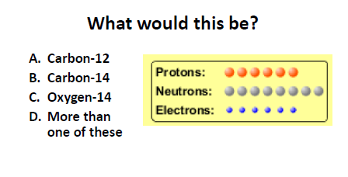
Your answer and explanation:

Question 10:
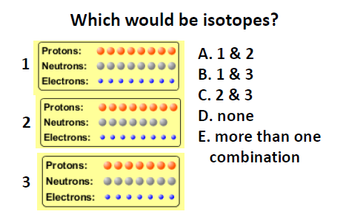
Your answer and explanation:

Question 11:
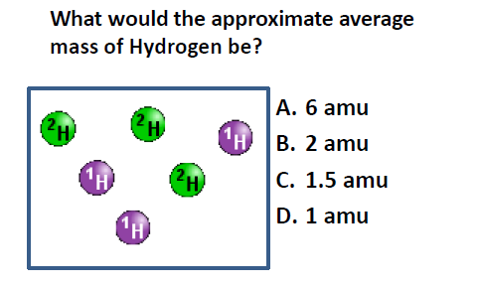
Your answer and explanation:

Question 12:
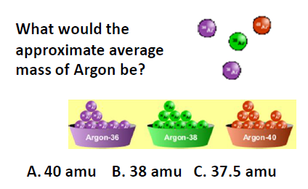
Your answer and explanation:

Question 13:
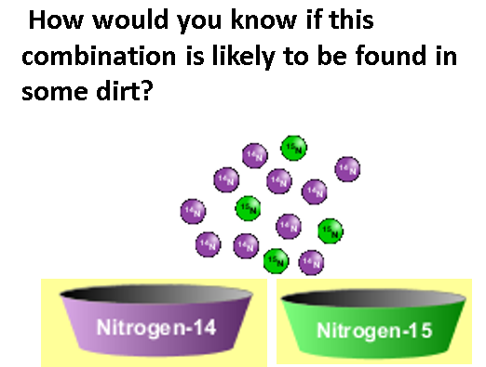
Your answer and explanation:

