pH Scale Remote Lab 2
(This‌ ‌lesson‌ is designed ‌for‌ ‌a‌ ‌student‌ ‌working‌ remotely‌.)‌
This lab uses the pH Scale simulations from PhET Interactive Simulations at University of Colorado Boulder, under the CC-BY 4.0 license.
https://phet.colorado.edu/sims/html/ph-scale/latest/ph-scale_en.html

Note about prior learning: Students should have completed pH Scale Basics Remote Lab1 or lessons with similar learning goals.

Learning Goals: Students will be able to
  - Determine if a solution is acidic or basic using
    - molecular size representations
    - H₃O⁺/OH⁻ ratio
    - Hydronium and/or Hydroxide concentration
  - Relate pH to H₃O⁺/OH⁻ ratio, Hydronium and/or Hydroxide concentration

Develop your understanding: Explore the Micro screen to see some ways that acids and bases are represented and measured.

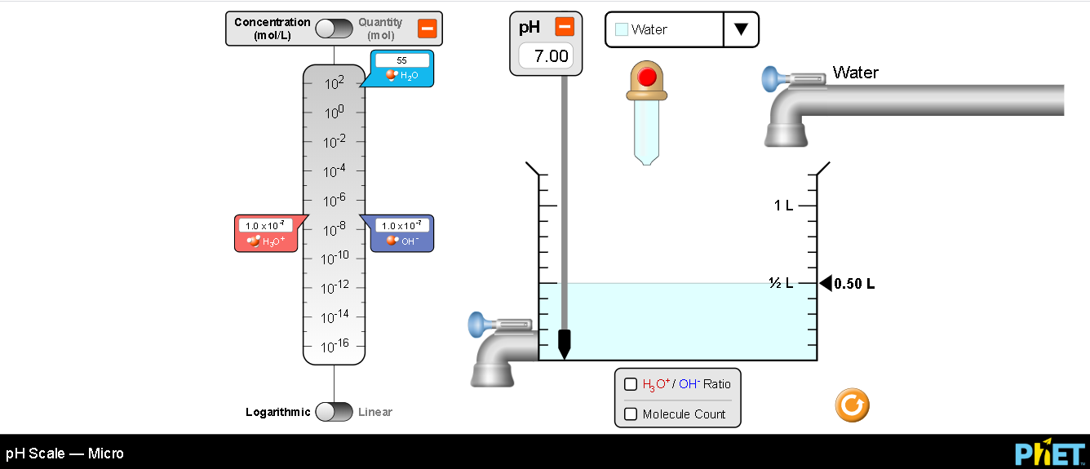

Explain your understanding:
- Use the Micro screen to explore moleculecular size representations of acids or bases.
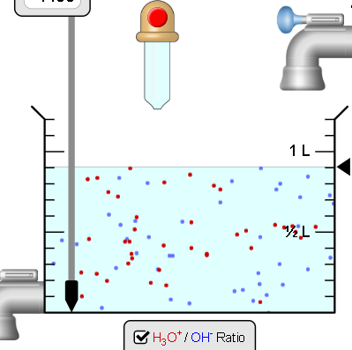
- Design experiments to gain a more quantitative understanding. Make sure to test changing the volume (add solution with the dropper or remove with the drain.) and diluting the solution by adding water..

- Describe your tests, observations, and conclusions. Include images for evidence.

- How does the moleculecular size representations compare to the pH?

- Describe how you could use the chart on the left of the screen to predict the relative acid or base characteristic of a solution:
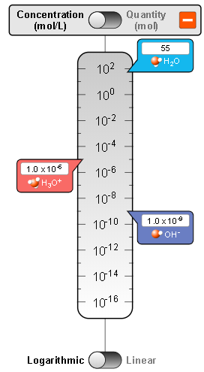

- What do you notice when the volume changes?

- What do you notice when the solution is diluted?

Expand your understanding mathematically:

- Calculate the H₃O⁺/OH⁻ ratio for solutions of your choice using all three values: the Molecule count, Quantity of moles, and Concentration Show your work
  - water
  - one base
  - one acid

- How do the H₃O⁺/OH⁻ ratio compare to the pH?

- Does adding solutions, water, or removing solution change any of your values in #3. If so, explain why changes in the container causes the ratio to change.

Open the full simulation pH Scale, then use the My Solution screen to help answer #6-8:

- If you measure the value of Hydronium concentration is 3.0x10⁻³ M/L, could you predict the solution to be acid, base, or neutral? Explain your answer.

- If you measure the number of Hydronium ions is 3.0x10¹² , could you predict the solution to be acid, base, or neutral? Explain your answer.

- If you measure the number of Hydroxide ions is 3.0x10⁻² moles, could you predict the solution to be acid, base, or neutral? Explain your answer.

Test your understanding and self-check: For each question, predict your answer and support your answer with an explanation. Then use the full pH Scale simulation to verify and add screen captures to your explanation.

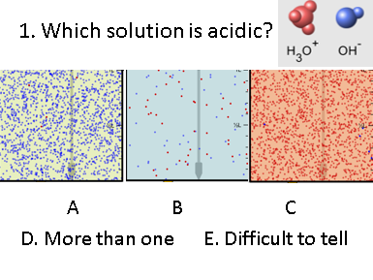
- Prediction and explanation with support

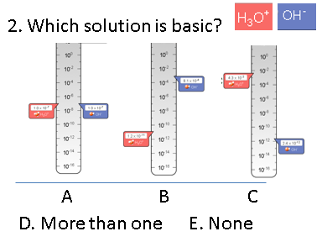
- Prediction and explanation with support

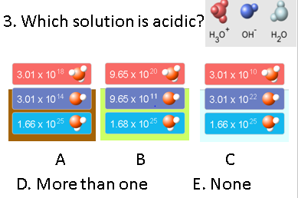
- Prediction and explanation with support

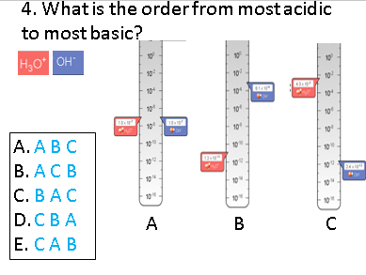
- Prediction and explanation with support

