- Fill in the table for this circuit. Show your work and then check your answer with PhET
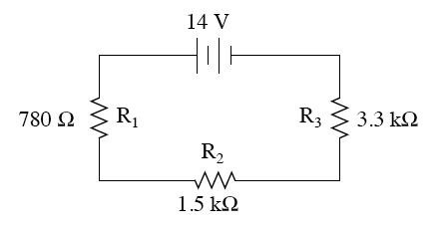
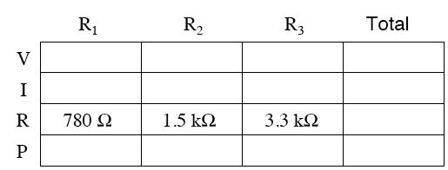

- A parallel circuit has 3 resistors each on different paths connected to a 120 V potential difference. The resistors have resistances of 5.0 Ω, 7.5 Ω, and 9.8 Ω?
Draw a picture of the circuit. Fill in the table for this circuit. Show your work and then check your answer with PhET.
Add units to measurements | 5.0 Ω | 7.5 Ω | 9.8 Ω | total
V ( )
I ( )
R ( )
P ( )

- For both circuits: Determine the potential difference on and the current through each resistor. Show your work and then check your answer with PhET
90.0 Ω
20.0 Ω
30.0 Ω 50.0 Ω

3.0 Ω
9.0 Ω
12.0 V
6.0 Ω

- Construct a complex circuit that will produce _Get value from instructor)_total resistance using PhET. Draw your diagram.
Use: 9 V battery , resistors: 220 KΩ, 100 KΩ, 50 KΩ, 40 KΩ, wire

