Learning Goals: Students will be able to:
- Explain how the range, uncertainty and number of data points affect correlation coefficient and Chi squared.
- Describe how correlation coefficient and chi squared can be used to indicate how well a curve describes the data relationship.
- Apply understanding of Curve Fitting to designing experiments

Directions:
Without changing any of the uncertainty bars, explore Curve Fitting to answer 1-4:

- For each of the four types of curve fit, what is the minimum number of points to get a good correlation and a curve that demonstrates the known shape for the curve?

- For each of the four types of curve fit, what is the minimum number of points to get in the green zone for χ² and a good correlation?

- How can you desensitize the coefficient to variation in data? (In other words, if you collect data that would not fit on the line, under what conditions would r² stay nearly the same?) Is χ² desensitized the same way?

- Summarize the relationship between the χ² red zone and the correlation coefficient. Include illustrations or screen captures to support your reasoning.

- Explore how varying the uncertainty bars affects χ² and r² and then answer these questions.

- Two experiments were run and these graphs show the results. Which experiment has a curve fit that describes the relationship the best? What is your reasoning? Describe what is different about the data that made the quality of the fit change.
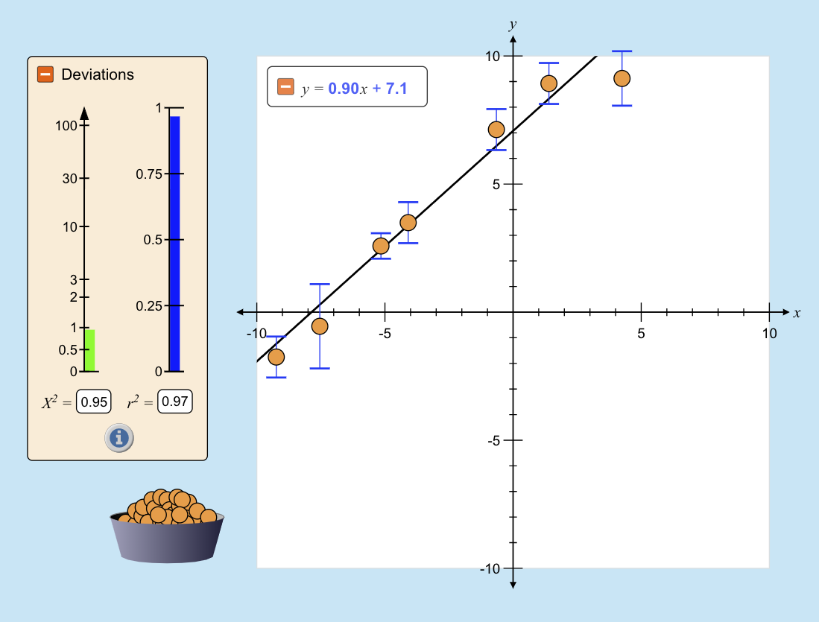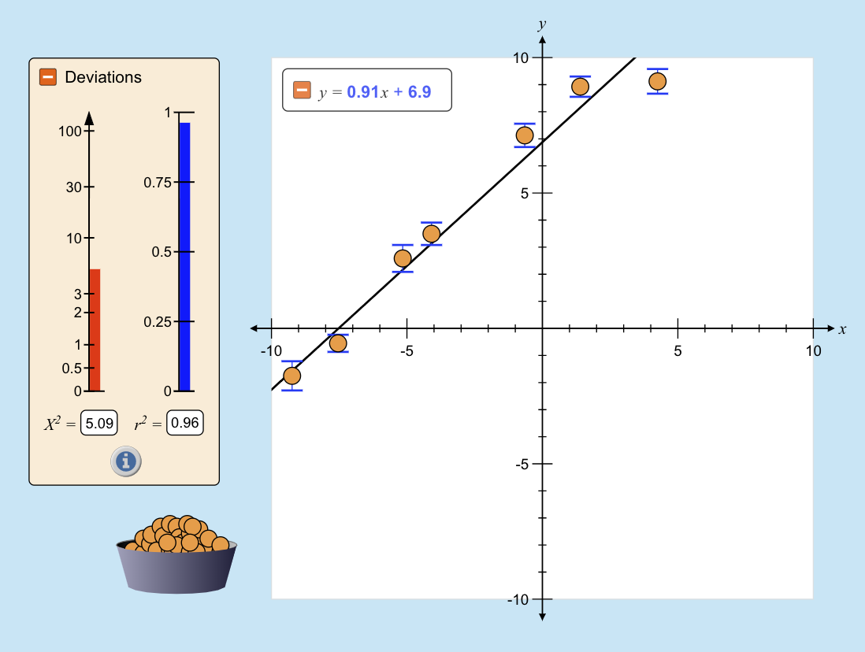

- Which is best and why?

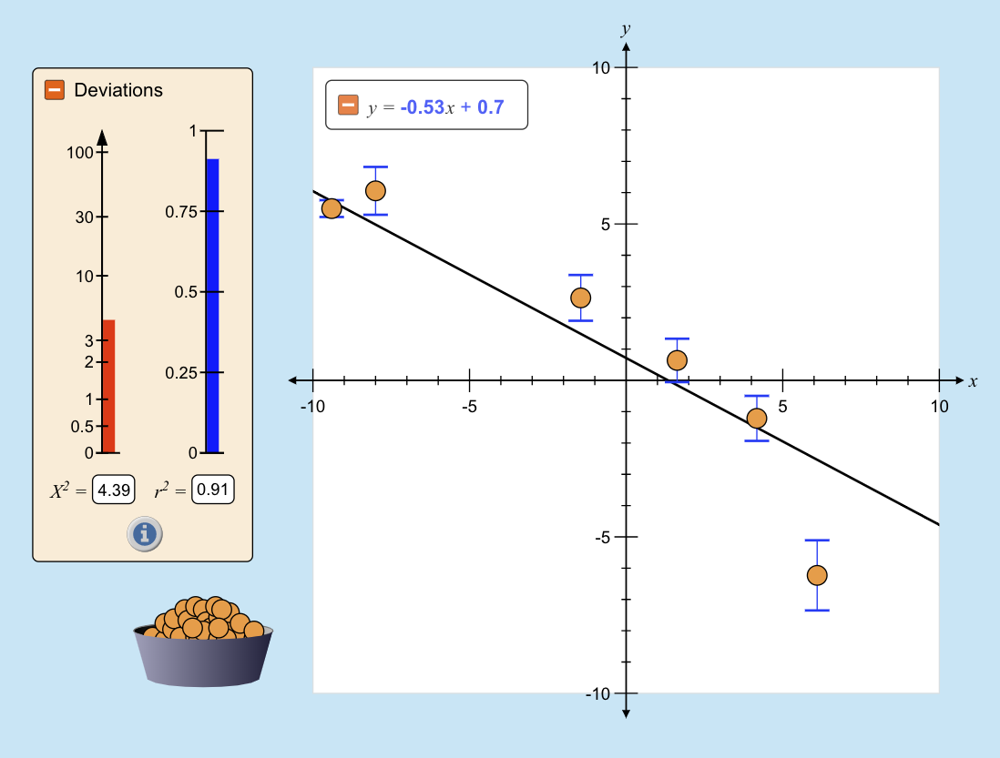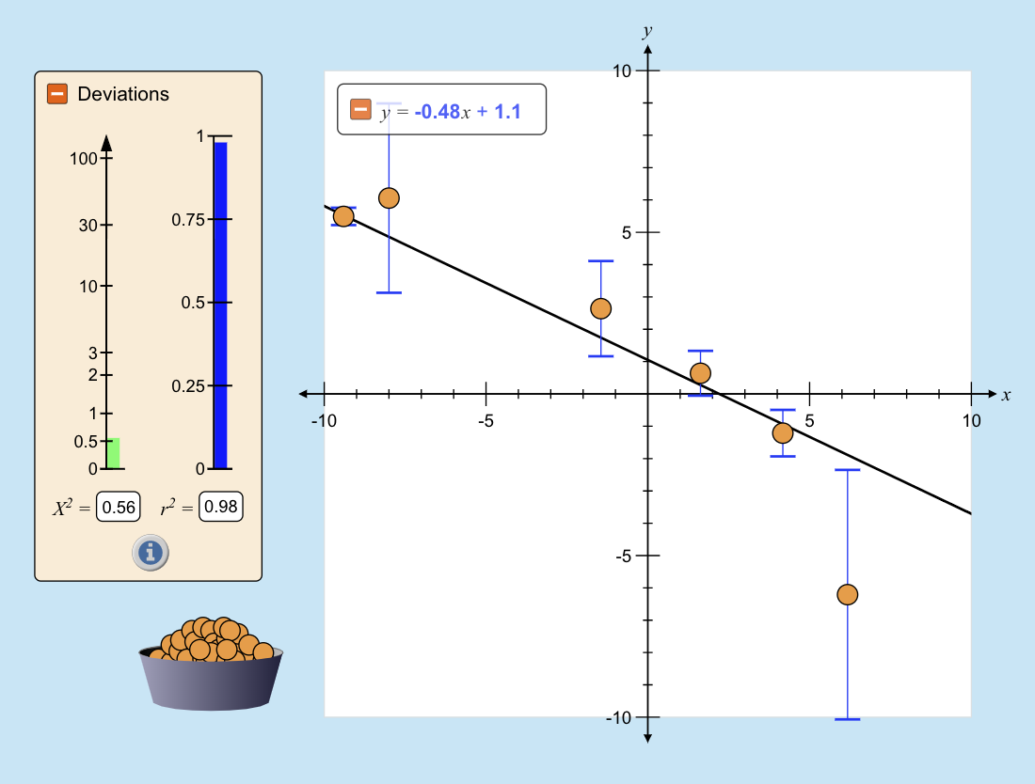

- Which is best and why?

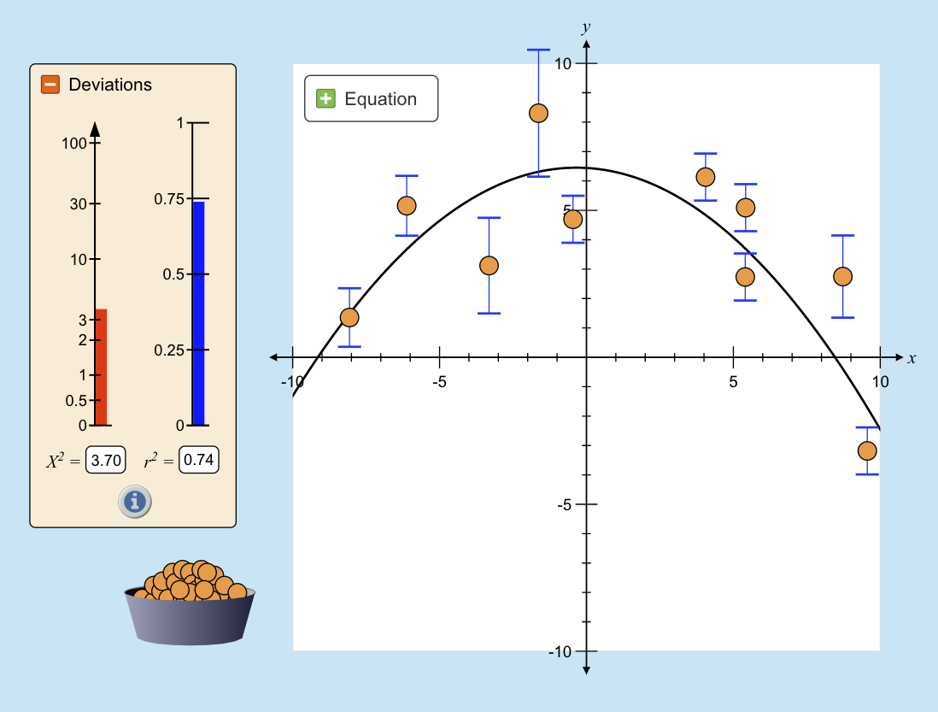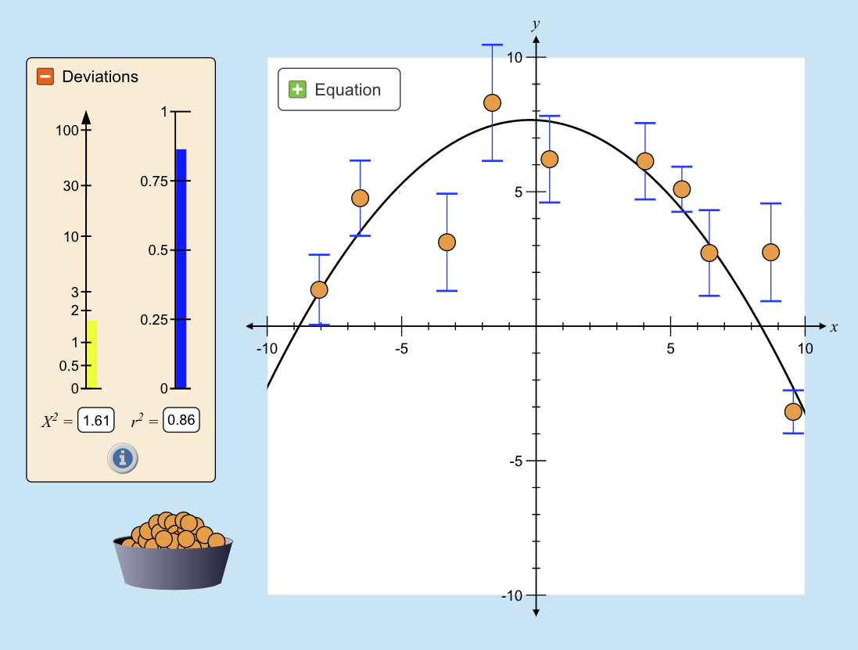

6. How does your understanding of χ² and r² help you with experimental design?

