Reactants, Products, and Leftovers Remote Lesson 1
Introduction to Chemical reactions
(This‌ ‌lesson‌ is designed ‌for‌ ‌a‌ ‌student‌ ‌working‌ remotely‌.)‌
This lab uses the Reactants, Products, and Leftovers simulation from PhET Interactive Simulations at University of Colorado Boulder, under the CC-BY 4.0 license.
https://phet.colorado.edu/sims/html/reactants-products-and-leftovers/latest/reactants-products-and-leftovers_en.html

Learning Goals:
Students will be able to:
- Relate the real-world example of making sandwiches to chemical reactions
- Describe what “limiting reactant” means using examples of sandwiches and chemicals.
- Identify the limiting reactant in a chemical reaction

Develop your understanding:
- Open the Sandwiches screen, then explore to create your own sandwiches and then see how many sandwiches you can make with different amounts of ingredients.
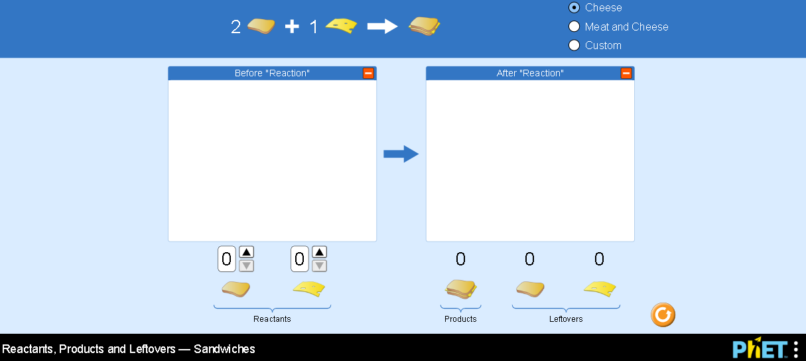

Explain your understanding:

- Predict (without using the sim) how many cheese sandwiches, as defined by the picture to the right, you can make if you have 6 pieces of bread and 4 slices of cheese.____
- Describe your thinking:

- Use the simulation to check your answer.
- Do you have different ideas that would help predict the number of sandwiches you could make?

- Predict what would change about your number of sandwiches and your thinking if you had the same 6 pieces of bread and 4 slices of cheese, but the sandwich is made like the picture on the right?___
- Check your prediction using the simulation and describe any new ideas you have to make predictions.
- Why did the number of sandwiches change from #2 even though the amounts of ingredients were the same?
- Research what “limiting reactant” means and then write a description in your own words using the situations in #2 and #3 as supporting evidence. (cite references)

- A tricycle factory gets a shipment with 400 seats and 600 wheels. Use your ideas about Limiting Reactants to explain how you would figure out how many tricycles can be made.

Test your understanding:
Question 1
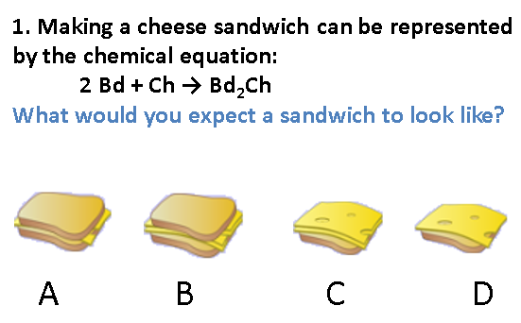Your answer and explanation:

Question 2
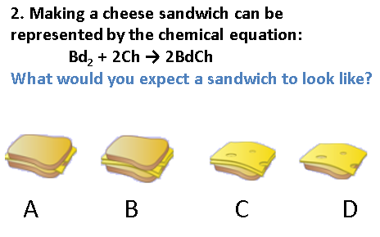Your answer and explanation:

Question 3
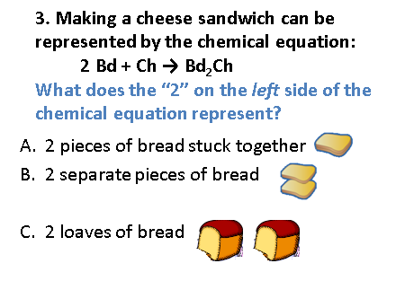Your answer and explanation:

Question 4
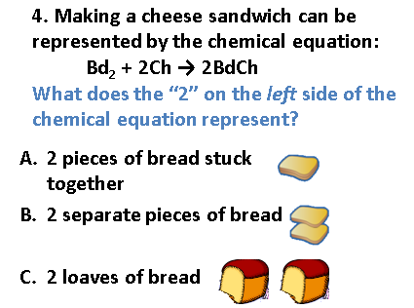Your answer and explanation:

Question 5
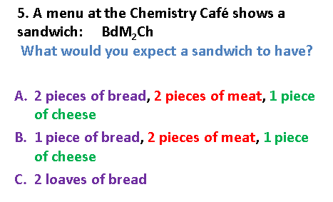Your answer and explanation:

Question 6
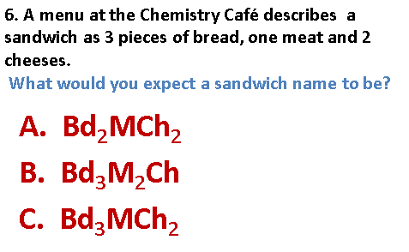Your answer and explanation:

Question 7 The Chemistry Cafe was out of bread. The cook went next door to the bakery and bought a loaf of bread which has 33 slices. Then, she sells 12 sandwiches (two pieces of bread per sandwich). How much bread did she have left? Explain your answer.

Question 8 The Chemistry Cafe cook has a loaf which has 33 slices and a package of cheese that has 15 pieces. She is making sandwiches that have 2 pieces of both bread and cheese. How many sandwiches can she make? Explain your answer.

Relate the model to Chemistry: Open the Molecules screen, then explore a few common reactions and see how the reactants’ amounts yield products.
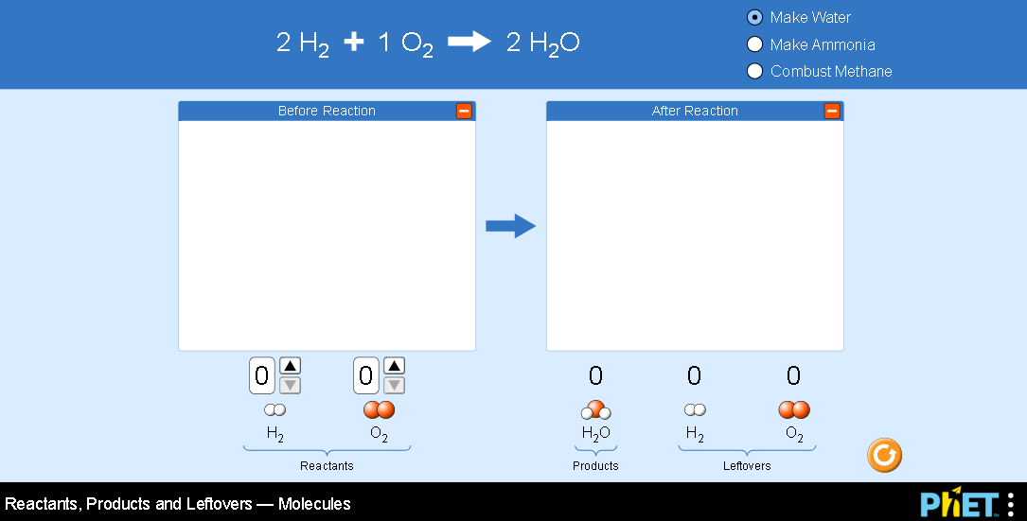

- The balanced chemical reaction for producing water is: 2 H₂ + 1 O₂ 2 H₂O.
Research the “The Law of Definite Proportions” and explain why the simulation doesn’t have choices for the ratio of hydrogen and oxygen like it does for cheese, bread, and meat.(cite references)

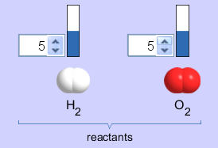
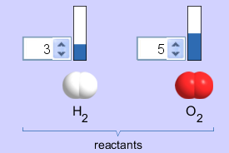
- Predict which reactant amounts would get the most water with the least amount of leftovers. Explain how your understanding of Limiting Reactant helped you figure this out.
5
5
3
5
3
5
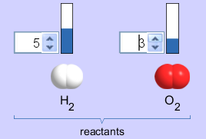

Go further in your understanding: Do lesson 2 by Loeblein

