Arithmetic ‌Lab ‌
(This‌ ‌lesson‌ is designed ‌for‌ ‌a‌ ‌student‌ ‌working‌ remotely‌.)‌

This lab uses the Arithmetic simulation from PhET Interactive Simulations at University of Colorado Boulder, under the CC-BY 4.0 license.
https://phet.colorado.edu/en/simulation/arithmetic

Learning Goals: Students will be able
- Explain how the multiplication tables help understand multiply, factor and divide.
- Increase accuracy in multiplying, factoring and dividing.

Part A: Explore and make sense of Multiply, Factor, and Divide

- Play the Multiply game for a few minutes.
  - Write a strategy for using the table to get a high score:
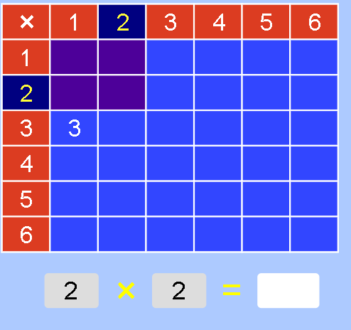

  - Test your strategy by playing the game until the table is completely filled in.When you complete the game, capture the screen with your score and paste it below:

  - Did you have to change your strategy or do you have other ideas to make you get a better score?

- Play the Factor game for a few minutes.
  - Write a strategy for using the table to get a high score.

  - Test your strategy by playing the game until the table is completely filled in.When you complete the game, capture the screen with your score and paste it below:

  - Did you have to change your strategy or do you have other ideas to make you get a better score?

  - How does Multiplying compare to Factoring?

- Play the Divide game for a few minutes.

  - The Game is called “Divide”, so why can the math problem looks like this:
  - What clues can you get from the table to help you get a good score? 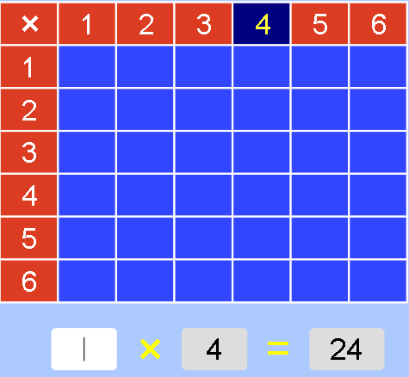

  - Test your thinking by playing the game until the table is completely filled in.When you complete the game, capture the screen with your score and paste it below:

  - Did you have to change your strategy or do you have other ideas to make you get a better score?

- Describe in your own words how multiplying, factoring, and dividing are related.

- Each game has three levels. Explore to see what makes each Multiply level more difficult..
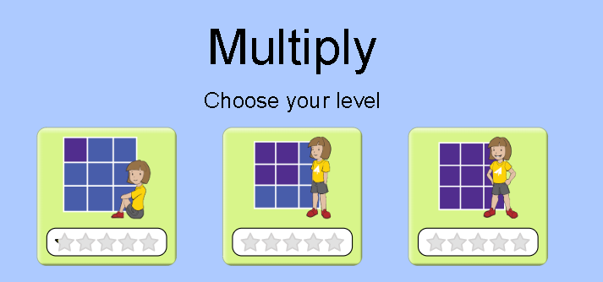
Explain what makes the levels more difficult or different:

- Explore each level of Factor and Divide game. Explain what makes the levels more difficult or different: Did you have to change your strategies or do you have other ideas to make you get a better score?

Part B: Show your Skills

Play each level of each game. Copy and paste your final results like this
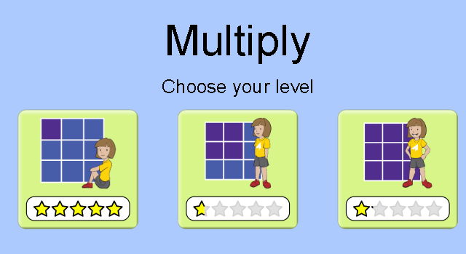

Extra challenge: For an extra challenge, you can turn on the timer and see if you can improve your skills.

