Balloons and Static Electricity and John Travoltage Remote lab ‌
(This‌ ‌lesson‌ is designed ‌for‌ ‌a‌ ‌student‌ ‌working‌ remotely‌.)‌

This lab uses the Balloons and Static Electricity and John Travoltage Remote lab simulation from PhET Interactive Simulations at University of Colorado Boulder, under the CC-BY 4.0 license.
https://phet.colorado.edu/sims/html/balloons-and-static-electricity/latest/balloons-and-static-electricity_en.html
https://phet.colorado.edu/sims/html/john-travoltage/latest/john-travoltage_en.html

Learning Goals: Students will be able to describe and draw models for common static electricity concepts. (transfer of charge, induction, attraction, repulsion, and grounding)

Develop your understanding:
- Open Balloons and Static Electricity, then explore to develop your own ideas about electrical charge.
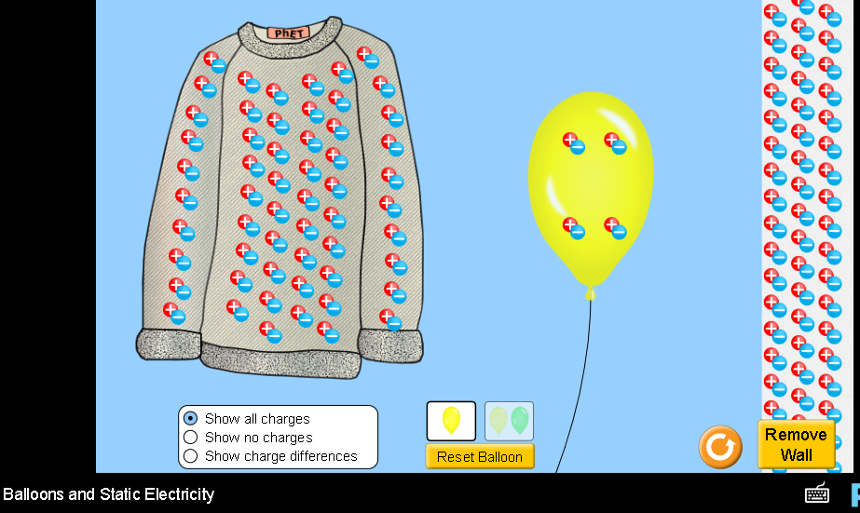
Describe several of your experiments and your observation with captured images from the simulation.
- .
- ...

2. Open John Travoltage , then explore to develop your own ideas about electrical charge.
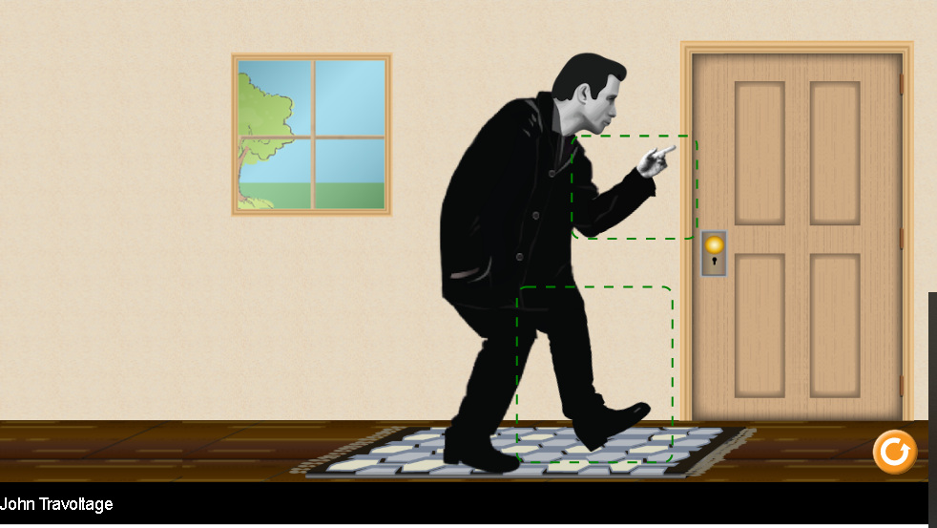
Describe several of your experiments and your observation with captured images from the simulation.
- .
- ...

Test your understanding: Without using the simulations, predict the answers to these questions, then use the simulation to check your ideas.

Question 1 When the balloon is rubbed on the sweater, what might happen?

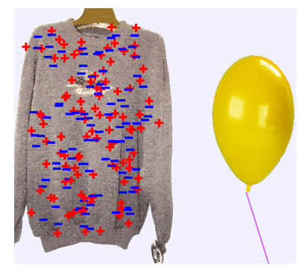
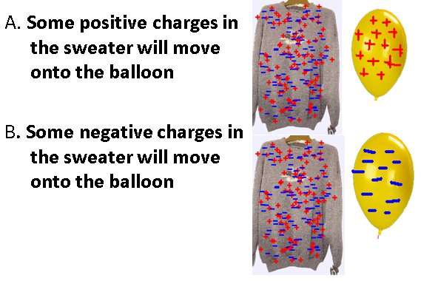
What do you predict for the answer?
Describe an experiment and include images from the simulation that supports your answer.

Question 2 What do you think will happen when the balloon is moved closer to the wall?
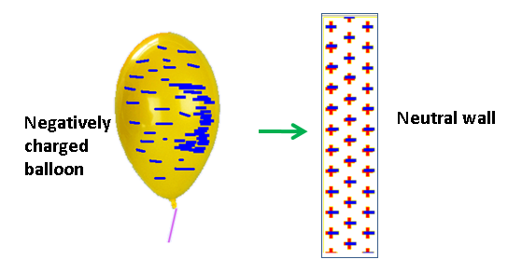

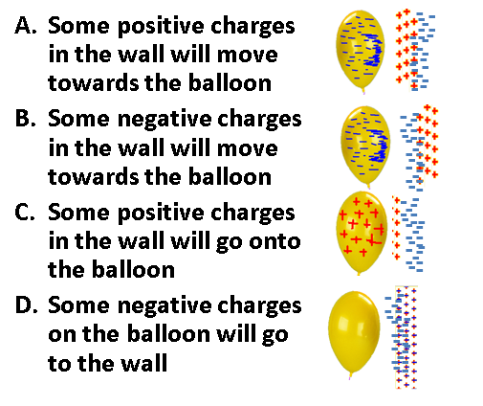
What do you predict for the answer?
Describe an experiment and include images from the simulation that supports your answer.

Question 3 What do you think the balloons will do?
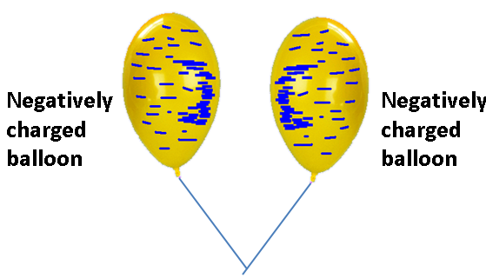
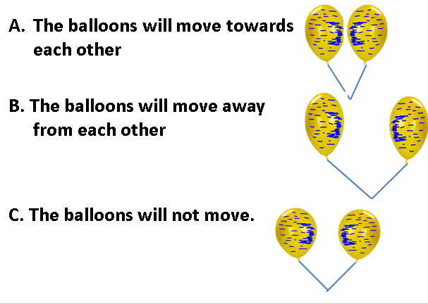
What do you predict for the answer?
Describe an experiment and include images from the simulation that supports your answer.

Question 4 What might happen to the charge on the man when he touches the door knob?
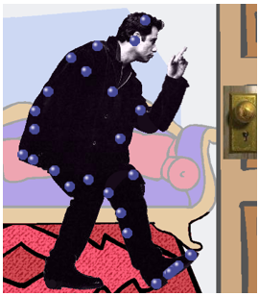

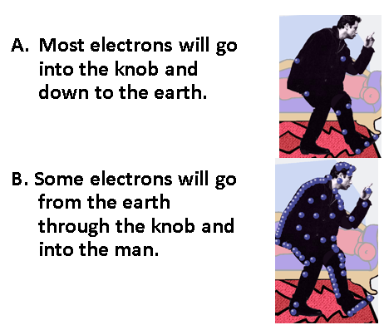
What do you predict for the answer?
Describe an experiment and include images from the simulation that supports your answer.

