Projectile Motion
(This‌ ‌lesson‌ is designed ‌for‌ ‌a‌ ‌student‌ ‌working‌ remotely‌.)‌

This lab uses the Projectile Motion simulation from PhET Interactive Simulations at University of Colorado Boulder, under the CC-BY 4.0 license.
https://phet.colorado.edu/sims/html/projectile-motion/latest/projectile-motion_en.html

Learning Goals: Students will be able to
- Predict how varying initial conditions affect a projectile path
- Use reasoning to explain the predictions.
- Explain projectile motion terms in their own words.
- Describe why using the simulation is a good method for studying projectiles.

Everyday Physics in your life:
1. As you get ready for bed, you roll up one of your socks into a tight ball and toss it into the laundry basket across the room. Then, you try to toss the other sock without rolling it up.. What effects whether or not your socks land in the basket?

Develop your understanding:
2. Use Intro screen to test your ideas about the things that affect the landing location of a projectile.
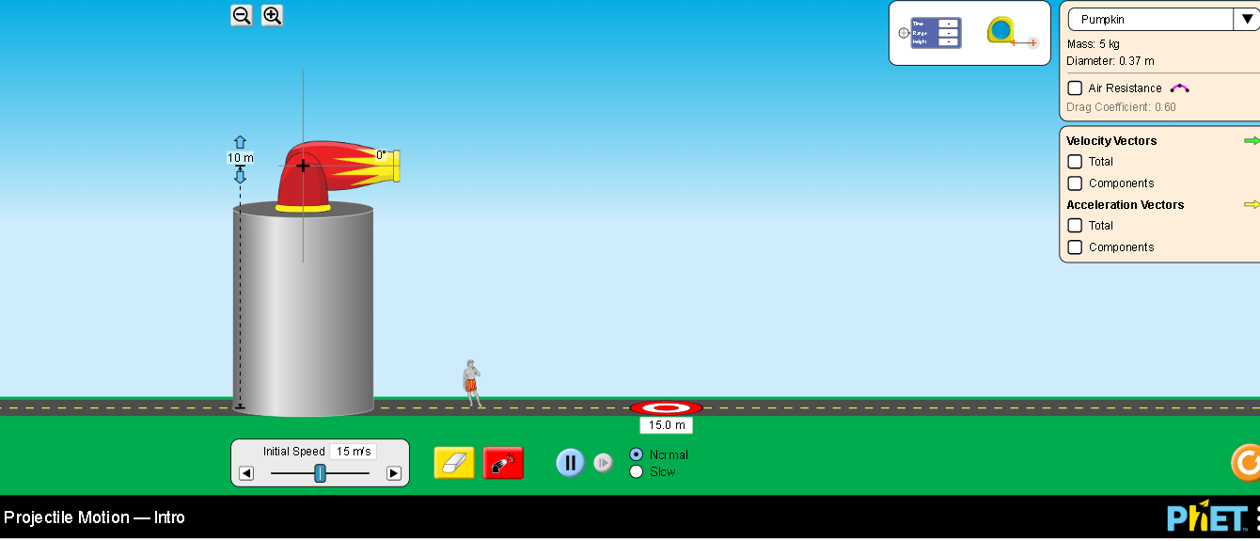
- Make a complete list of things that affect the landing site of a projectile including your ideas from question #1 and any discoveries you made using the simulation.
- Next to each item, briefly explain why you think the landing location changes.

3. What is meant by the expression “flight path of a projectile”? Draw the flight path of your socks and describe the shape. Use the simulation to investigate how the items you listed in #2 affect the shape of the flight path. Summarize your discoveries including explanations for the different flight paths.

4. Suppose your friend asks you to tell them about projectiles. You start to explain, but she interrupts. “Wait,” she says, “You’re using a lot of words I don’t understand. Can you explain in English?” Knowing that a picture is worth a thousand words, you draw a picture of a projectile path and label all the terms that are on the simulation page. Draw a picture like you would for your friend and write what you would tell her about the terms. Insert an image of your drawing if you can.

5. Describe in your own words why using the simulation is a good method for studying projectiles. Include the error sources the simulation eliminates (or minimizes) and what representations the simulation provides that are helpful.

Expand your understanding:
6. Use the Lab screen to expand your ideas about what affects the landing location and path of a projectile. List any discoveries you made to identify additional things that affect the landing site of a projectile and/or path of a projectile. Next to each item, briefly explain why you think the motion of the projectile is affected..

7. Compare your everyday experiences to the simulation. Design a few tests like rolling things off a table or tossing some things into a basket or bowl to determine how well the simulation represents projectile motion. Some good objects are tightly rolled socks or paper crumpled into a ball.Write about your experiments and compare them to the simulation.

Test your understanding and self check: For each question, predict your answer and support your answer with an explanation. Then use the Lab screen to verify and add screen captures to your explanation.

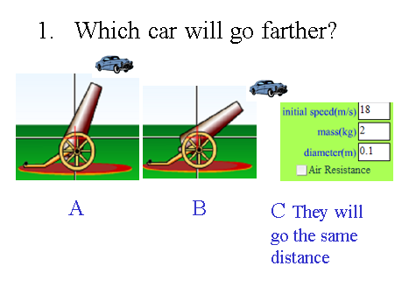
- Prediction and explanation with support

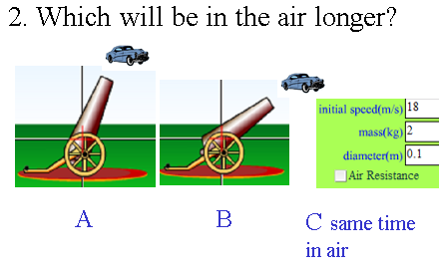
- Prediction and explanation with support

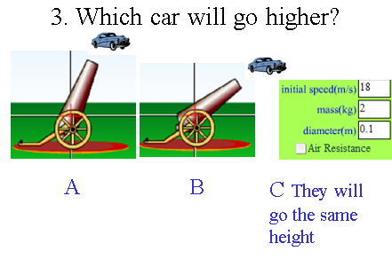
- Prediction and explanation with support

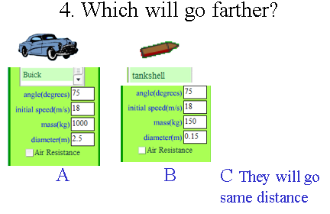
- Prediction and explanation with support

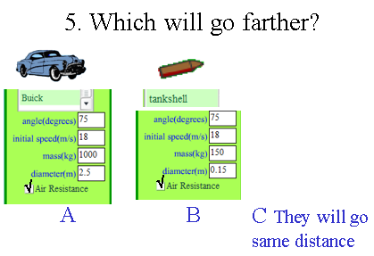
- Prediction and explanation with support

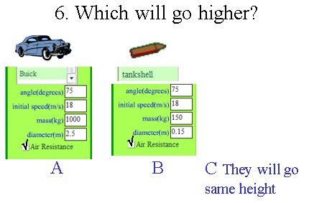
- Prediction and explanation with support

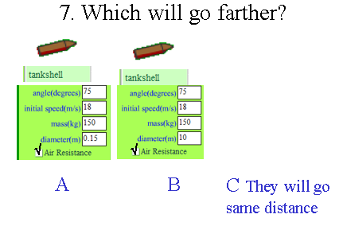
- Prediction and explanation with support

