Waves on a String Remote Lab

This lab uses the Waves on a String simulation from PhET Interactive Simulations at University of Colorado Boulder, under the CC-BY 4.0 license.
https://phet.colorado.edu/sims/html/wave-on-a-string/latest/wave-on-a-string_en.html

Learning Goals: Students will be able to:
- Discuss waves’ properties using common vocabulary.
- Predict the behavior of waves through varying mediums and at reflective endpoints.
- Use scientific vocabulary for wave properties and behavior.

Develop your understanding: Open Waves on a String, then investigate wave behavior. As you explore, think about how you would describe waves and some reasons the waves might act the way they do.
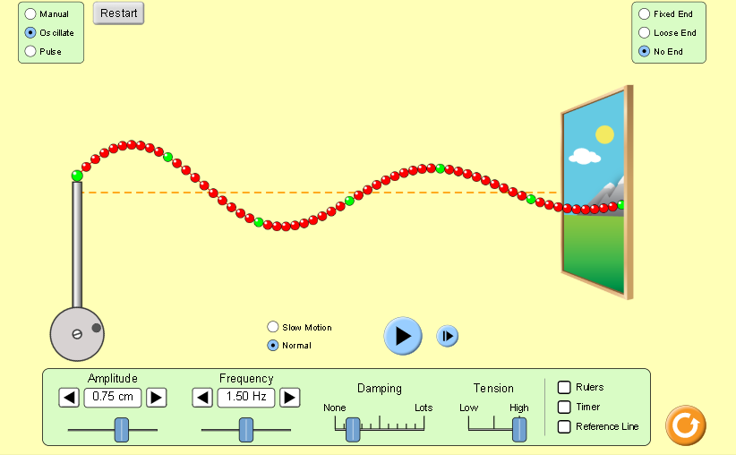

Explain your understanding:

- Write a list of characteristics to describe the waves. Describe each characteristic in your own words so that any person could understand waves. Use images to help with the descriptions.
Tips: Later during this lab, you will relate your own descriptions to scientific ones. It is important that you have your own words to begin your learning, so don’t do any research yet. Also, learning is best when you make your own drawings. Perhaps you can insert images of your own drawings. if not then use images from Waves on a String that look like your drawings.

Wave Characteristics:

  - etc..

Expand your understanding:
For steps 2-5 Investigate waves with Oscillate 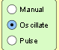 and No End 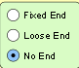
Tips: Helpful tools and 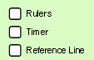

- Use the Amplitude slider. Answer the questions; include images
  - Define Amplitude in everyday language.

  - Explain how the wave behaves as the Amplitude changes using the characteristics you described in #1

- Use the Frequency slider. Answer the questions; include images.
- Define Frequency in everyday language.

- Explain how the wave behaves as the Frequency changes using the characteristics you described in #1

- Use the Tension slider. Answer the questions; include images.
a. Define Tension in everyday language.

b. Explain how the wave behaves as the Tension changes using the characteristics you described in #1

- Use the Damping slider. Answer the questions; include images.
a. Define Damping in everyday language.

b. Explain how the wave behaves as the Damping changes using the characteristics you described in #1

- Hold the end of a real rope or the corner of a blanket. Shake to make several waves.
  - How can you change the Amplitude of the wave?
  - How can you change the Frequency of the wave?
  - Did you make waves more like Manual, Oscillate or Pulse?

  - Use the simulation to show how your real experiment would look for changing Amplitude.
(Explain your experiment and insert images here)

  - Use the simulation to show how your real experiment would look for changing Frequency .
(Explain your experiment and insert images here)

Practice applying your understanding:

- A wave was generated by Oscillation and paused at two different times.
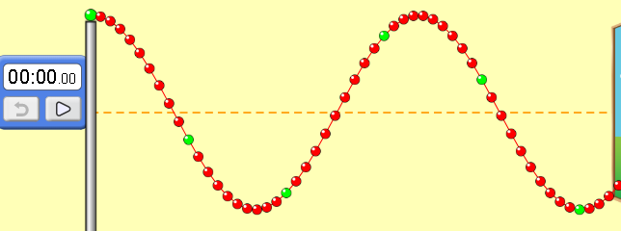
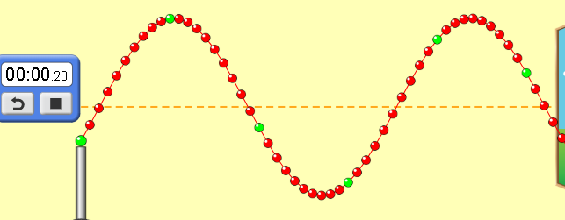

Describe differences and similarities in the characteristics of the wave at different times.

Investigate for understanding:
- Make a wave with the Oscillator with no Damping
- Measure the vertical and horizontal location of a green ball with the ruler and record the time.
Use to collect data to make a data table of the time, vertical and horizontal positions of the same green ball. Make sure to include observations when the green ball is above and below the middle line.
time | vertical (cm) | horizontal (cm)

- Make graphs of vertical position versus time and horizontal position versus time. Describe or include images of each graph.

- How do the graphs help you understand the characteristics of waves?

- Predict how the graphs will look if you increase the damping.
Test your ideas and explain why damping affects the graphs.

9. Investigate how waves behave with other settings: Fixed, Loose, Manual, Pulse. Write a summary of your observations including images for evidence.

Test your understanding:
The figure below shows a rope on a smooth floor with a knot at point A. Someone has shaken the end sideways to make a pulse. You are looking down and taking a movie of the motion. Below is one freeze frame of the movie.
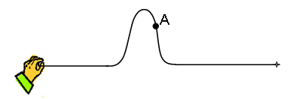
Underline your answer for each situation:
- If you advance the movie one frame, the knot at point A would be
a) in the same place b) higher c) lower d) to the right e) to the left
- If the person generates a new pulse like the first but more quickly, the pulse would be
a) same size b) wider c) narrower
- If the person generates another pulse like the first but he moves his hand further, the pulse would be
a) same size b) taller c) shorter
- If the person generates another pulse like the first but the rope is tightened, the pulse will move
a) at the same rate b) faster c) slower

Now the person moves his hand back and forth several times to produce several waves. You freeze the movie and get this snapshot.
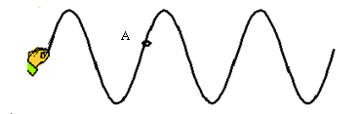
Underline your answer for each situation:
- If you advance the movie one frame, the knot at point A would be
a) in the same place b) higher c) lower d) to the right e) to the left

- If you advance the movie one frame, the pattern of the waves will be _________relative to the hand.
a) in the same place
b) shifted right
c) shifted left
d) shifted up
e) shifted down

- If the person starts over and moves his hand more quickly, the peaks of the waves will be
a) the same distance apart b) further apart c) closer together

- If you lower the frequency of a wave on a string you will
- lower its speed. b) increase its wavelength. c). lower its amplitude. d) shorten its period.

9. Consider this wave approaching a fixed end
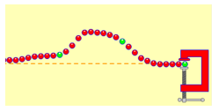
Which shows the wave after it reflects?

